MULTI-BRANCH
ENTERPRISE NETWORK
Cisco Packet Tracer | Network Configuration & Security Testing
Technical portfolio report
Prepared as evidence of network design, configuration, troubleshooting and validation
Prepared by: Chelsey Lauren Pillay

1. Project overview
This report documents the SecureNet Solutions simulated multi-branch enterprise network built in Cisco Packet Tracer. The design connects Johannesburg, Durban and Cape Town through a routed WAN, with a separate Internet Edge router and an external test server. Implemented features include VLAN segmentation, router-on-a-stick inter-VLAN routing, DHCP, OSPF, guest ACL restrictions, SSH management, a simulated internal web server, NAT/PAT and connectivity testing.

Project objectives
- Build connectivity between the network routers and branch networks.
- Organise hosts into the intended IP networks and VLANs.
- Use DHCP to provide client addressing where configured.
- Use OSPF to exchange routes between participating routers.
- Restrict guest traffic with access-control rules and validate permitted/blocked traffic.
- Harden network-device management with SSH and verify server reachability.
Implementation note: This report is based on the project details and tests recorded during configuration. Verification commands are included for repeatable checks. Before publishing to GitHub, review screenshots for readability, confirm the saved .pkt file matches the report, and remove passwords or other secrets from any configuration exports.

2. Network topology and design
The topology contains four routers: R1-JOHANNESBURG, R2-DURBAN, R3-CAPE-TOWN and R4-INTERNET-EDGE. R1, R2 and R3 form a triangle WAN using three /30 serial links and OSPF area 0. R1 connects to R4 over 172.16.0.0/30. R4 connects to the external test server network 203.0.113.0/24. Branch access switches carry the relevant VLANs, while the Johannesburg server-farm switch connects the internal DNS/DHCP and web servers.
Design area | Purpose | Evidence to capture
Routers R1–R4 | Route traffic between connected networks and participate in the intended routing design. | Full topology and each router's interface summary
Access switches / VLANs | Separate device groups and apply the intended Layer 2 design. | VLAN table and switch port assignments
DHCP | Assign IP settings to client devices automatically where configured. | Client IP configuration and DHCP bindings
OSPF | Advertise and learn routes between participating routers. | OSPF neighbors and routing table
Guest ACL | Allow required guest traffic while restricting protected networks. | ACL configuration plus positive and negative tests
Server | Provide the configured service and confirm reachability from permitted networks. | Server IP settings and successful connectivity test

3. IP addressing and VLAN table
The addressing plan below records the VLANs and subnets configured in the simulation. Durban staff deliberately uses 10.20.10.0/24 (not 10.20.110.0/24). Guest VLAN IDs and their subnet numbers do not always match; for Cape Town guest, VLAN 260 uses 10.30.26.0/24 because 10.30.260.0/24 is not a valid IPv4 subnet.
Site / device group | VLAN ID | Network / prefix | Default gateway | DHCP range | Notes
Johannesburg management | 10 | 10.10.10.0/24 | 10.10.10.1 | 10.10.10.10–10.10.10.254 | DHCP pool JHB-MANAGEMENT
Johannesburg finance | 20 | 10.10.20.0/24 | 10.10.20.1 | 10.10.20.10–10.10.20.254 | Example client: 10.10.20.10
Johannesburg HR | 30 | 10.10.30.0/24 | 10.10.30.1 | 10.10.30.10–10.10.30.254 | DHCP pool JHB-HR
Johannesburg IT | 40 | 10.10.40.0/24 | 10.10.40.1 | 10.10.40.10–10.10.40.254 | DHCP pool JHB-IT
Johannesburg servers | 50 | 10.10.50.0/24 | 10.10.50.1 | Static servers | DNS/DHCP-labelled server .10; web server .20
Johannesburg guest | 60 | 10.10.60.0/24 | 10.10.60.1 | 10.10.60.10–10.10.60.254 | Guest ACL applied inbound
Johannesburg network management | 99 | 10.10.99.0/24 | 10.10.99.1 | Not documented | VLAN created; client pool not recorded
Durban staff | 110 | 10.20.10.0/24 | 10.20.10.1 | 10.20.10.10–10.20.10.254 | Important: staff subnet is 10.20.10.0/24
Durban IT | 140 | 10.20.140.0/24 | 10.20.140.1 | 10.20.140.10–10.20.140.254 | DHCP pool DBN-IT
Durban guest | 160 | 10.20.160.0/24 | 10.20.160.1 | 10.20.160.10–10.20.160.254 | Guest ACL applied inbound
Cape Town staff | 210 | 10.30.210.0/24 | 10.30.210.1 | 10.30.210.10–10.30.210.254 | DHCP pool CPT-STAFF
Cape Town IT | 240 | 10.30.240.0/24 | 10.30.240.1 | 10.30.240.10–10.30.240.254 | DHCP pool CPT-IT
Cape Town guest | 260 | 10.30.26.0/24 | 10.30.26.1 | 10.30.26.10–10.30.26.254 | VLAN 260 uses subnet 10.30.26.0/24
WAN R1–R2 | N/A | 10.255.0.0/30 | Point-to-point | Static interface IPs | R1 .1; R2 .2
WAN R1–R3 | N/A | 10.255.0.4/30 | Point-to-point | Static interface IPs | R1 .5; R3 .6
WAN R2–R3 | N/A | 10.255.0.8/30 | Point-to-point | Static interface IPs | R2 .9; R3 .10
R1–R4 transit | N/A | 172.16.0.0/30 | Point-to-point | Static interface IPs | R1 172.16.0.1; R4 172.16.0.2
External test network | N/A | 203.0.113.0/24 | 203.0.113.1 | Static server | SRV-EXTERNAL-TEST: 203.0.113.10
Branch DHCP pools exclude addresses .1 through .9 for gateways and reserved addresses. Client addresses are assigned dynamically from the remaining range. Use show vlan brief on switches and show ip interface brief on routers to verify VLAN membership and Layer 3 interfaces.

4. Router configurations — R1, R2, R3 and R4
The router roles and key interfaces are summarised below. Use the verification commands in each section to confirm live state in Packet Tracer. Full running-config exports should be stored separately and sanitised before public release.

R1 — interface and routing configuration
R1-JOHANNESBURG: gateway subinterfaces are configured on GigabitEthernet0/0 for VLANs 10, 20, 30, 40, 50, 60 and 99, using 10.10.10.1, 10.10.20.1, 10.10.30.1, 10.10.40.1, 10.10.50.1, 10.10.60.1 and 10.10.99.1 respectively. Serial links connect to R2 (10.255.0.1/30) and R3 (10.255.0.5/30). R1 provides DHCP pools for Johannesburg clients, participates in OSPF area 0 and applies JHB-GUEST-FILTER inbound on G0/0.60.
enable
show ip interface brief
show ip route
show ip route ospf
show ip ospf neighbor
show ip dhcp pool
show ip dhcp binding
show access-lists JHB-GUEST-FILTER
show ip ssh

Verification commands: show ip interface brief; show ip route ospf; show ip ospf neighbor; show ip dhcp pool; show ip dhcp binding; show access-lists JHB-GUEST-FILTER; show ip ssh.

R2 — interface and routing configuration
R2-DURBAN: GigabitEthernet0/0 subinterfaces provide gateways for staff 10.20.10.1/24 (VLAN 110), IT 10.20.140.1/24 (VLAN 140) and guest 10.20.160.1/24 (VLAN 160). Serial links connect to R1 at 10.255.0.2/30 and R3 at 10.255.0.9/30. R2 provides DHCP pools, participates in OSPF area 0 and applies DBN-GUEST-FILTER inbound on G0/0.160.
enable
show ip interface brief
show ip route
show ip route ospf
show ip ospf neighbor
show ip dhcp pool
show ip dhcp binding
show access-lists DBN-GUEST-FILTER
show ip ssh

Verification commands: show ip interface brief; show ip route; show ip ospf neighbor; show ip dhcp pool; show ip dhcp binding; show access-lists DBN-GUEST-FILTER; show ip ssh.

R3 — interface and routing configuration
Purpose: document the router's connected networks, interface state, routing participation and any router-specific settings.
enable
show ip interface brief
show ip route
show ip route ospf
show ip ospf neighbor
show ip dhcp pool
show ip dhcp binding
show access-lists CPT-GUEST-FILTER
show ip ssh
R3-CAPE-TOWN: GigabitEthernet0/0 subinterfaces provide gateways for staff 10.30.210.1/24 (VLAN 210), IT 10.30.240.1/24 (VLAN 240) and guest 10.30.26.1/24 (VLAN 260). Serial links connect to R1 at 10.255.0.6/30 and R2 at 10.255.0.10/30. R3 provides DHCP pools, participates in OSPF area 0 and applies CPT-GUEST-FILTER inbound on G0/0.260.
Verification commands: show ip interface brief; show ip route; show ip ospf neighbor; show ip dhcp pool; show ip dhcp binding; show access-lists CPT-GUEST-FILTER; show ip ssh.

R4 — interface and routing configuration
Purpose: document the router's connected networks, interface state, routing participation and any router-specific settings.
enable
show ip interface brief
show ip route
show ip nat statistics
show ip nat translations
ping 203.0.113.10
show ip route 10.20.10.0
R4-INTERNET-EDGE: G0/0 uses 172.16.0.2/30 toward R1 and is marked NAT inside. G0/1 uses 203.0.113.1/24 toward SRV-EXTERNAL-TEST and is marked NAT outside. NAT overload translates source addresses from 10.0.0.0/8 to the G0/1 address. A static route for 10.0.0.0/8 via 172.16.0.1 was added during troubleshooting so replies to internal branch networks return through R1. R4 can ping the external server at 203.0.113.10, and a Durban staff PC subsequently reached it successfully.
Verification commands: show ip interface brief; show ip route; show ip nat statistics; show ip nat translations; ping 203.0.113.10. Check the return route with show ip route 10.20.10.0.

5. DHCP and OSPF configuration

DHCP
DHCP is configured on R1, R2 and R3 for the branch client networks. Pools use the corresponding VLAN gateway, DNS address 8.8.8.8, and exclusions for addresses .1–.9. The Johannesburg server at 10.10.50.10 is configured as a DNS/DHCP-labelled server in the topology, but client pools currently advertise 8.8.8.8; the intranet hostname did not resolve during testing. Access to the internal web page was verified by IP address instead.
show ip dhcp pool
show ip dhcp binding
show running-config | section dhcp

Observed result: the user confirmed that department PCs received addresses from the correct subnets. Example leases included JHB-FINANCE-01 at 10.10.20.10 and DBN-STAFF-01 at 10.20.10.10. Verification commands: show ip dhcp pool; show ip dhcp binding; on a client, Desktop > IP Configuration.

OSPF
OSPF process 1 runs in area 0 on R1, R2 and R3. Router IDs are 1.1.1.1, 2.2.2.2 and 3.3.3.3. The serial /30 WAN networks are advertised, along with the branch VLAN subnets. R1 was verified with OSPF neighbours in FULL state and learned routes to the Durban and Cape Town networks.
show ip ospf neighbor
show ip route ospf
show ip protocols

Observed result: OSPF neighbours reached FULL on R1 and remote branch routes appeared in the routing table. R2 showed an OSPF external default route via 10.255.0.1. Verification commands: show ip ospf neighbor; show ip route ospf; show ip route.

6. Guest ACL rules and security testing
Named extended ACLs restrict guest VLAN traffic from reaching protected internal networks. JHB-GUEST-FILTER is applied inbound on R1 G0/0.60; DBN-GUEST-FILTER on R2 G0/0.160; CPT-GUEST-FILTER on R3 G0/0.260. Each ACL includes a DHCP permit followed by denies for protected subnets and a final permit for other traffic. The recorded guest tests blocked pings to protected staff/server networks.
show access-lists
show running-config | include access-list
show ip interface

Test | Expected result | Observed result | Evidence / screenshot
DHCP on branch PCs | Address from correct subnet and gateway | Confirmed by user across departments; examples JHB 10.10.20.10 and DBN 10.20.10.10 | Add/retain DHCP client screenshot
OSPF neighbours | Expected branch neighbours FULL | R1 neighbours to R2 and R3 verified FULL | OSPF-Routing screenshot
Guest → protected internal destinations | Blocked | Guest pings to protected staff/server subnets failed as intended | ACL testing screenshot
Staff → internal web server | Allowed | JHB-FINANCE-01 pinged 10.10.50.20 and opened http://10.10.50.20 | Internal web/connectivity screenshot
Durban staff → external test server | Allowed through NAT/PAT | Initially timed out; after adding R4 return route via 172.16.0.1, ping succeeded | Capture final screenshot: External-Connectivity-Test.png
Intranet hostname lookup | Resolve to 10.10.50.20 | Not working because DHCP clients use DNS 8.8.8.8; IP-based web access works | Record as known limitation
Observed result: guest clients could not ping protected internal destinations, including Johannesburg finance/server/HR targets, Durban staff/finance targets and Cape Town staff targets. When documenting a blocked ping, include the source guest PC, destination IP and ACL counter/output where possible. Verification commands: show access-lists; show ip interface; show running-config.

7. SSH and device security
SSH version 2 is enabled on R1, R2 and R3. The routers use the securenet.local domain name, local username-based login, RSA keys and VTY lines configured for local login and SSH-only transport. An MOTD banner warns that access is for authorised users only. SSH status was checked with show ip ssh. Do not publish the lab username/password values or any secret strings.
show ip ssh
show running-config | section line vty
show running-config | include username
show running-config | include banner

Do not include passwords, secret values or private keys in the public portfolio. Screenshots should hide credentials and other sensitive values.

8. Server configuration and connectivity tests
The internal DNS/DHCP-labelled server uses 10.10.50.10/24 with gateway 10.10.50.1. The internal web server uses 10.10.50.20/24 with gateway 10.10.50.1. DNS contains intranet.securenet.local pointing to 10.10.50.20, but the hostname test failed because clients were configured to use 8.8.8.8. The web page was successfully opened by IP at http://10.10.50.20 from JHB-FINANCE-01. Guest access to the internal web server was blocked as intended.
show ip interface brief
show ip route
ping 10.10.50.20
ping 203.0.113.10
traceroute 203.0.113.10

Observed tests: SRV-INTERNAL-WEB pinged its gateway (10.10.50.1) successfully; JHB-FINANCE-01 pinged 10.10.50.20 and opened the HTTP page by IP. JHB-GUEST could not ping 10.10.50.20 because of the guest ACL. Verification commands: show ip interface brief; show ip route; ping 10.10.50.20; browse to http://10.10.50.20 from an allowed staff client.

9. Known limitations and troubleshooting results
The main observed issue was external connectivity from a branch client. NAT translations were created on R4, and R4 could ping SRV-EXTERNAL-TEST, but DBN-STAFF-01 initially timed out when pinging 203.0.113.10. Inspection of R4 routing table showed no route to the internal 10.0.0.0/8 networks. The following route was added: ip route 10.0.0.0 255.0.0.0 172.16.0.1. After the change, the Durban staff PC successfully pinged 203.0.113.10. This demonstrates the importance of the return route, not just NAT translation.
Issue / limitation | Troubleshooting performed | Final status / evidence
External ping from Durban PC timed out | Checked DHCP settings, OSPF default route, R1 return route and NAT translations; inspected R4 route table. Added ip route 10.0.0.0 255.0.0.0 172.16.0.1. | Resolved: DBN-STAFF-01 successfully pinged 203.0.113.10 after route was added. Capture final screenshot.
Intranet hostname did not resolve | Compared DNS record and DHCP-advertised DNS server. DNS record points intranet.securenet.local to 10.10.50.20, but clients use 8.8.8.8. | Known limitation; internal website was tested successfully by IP address.
Guest access to protected networks | Tested guest pings and checked ACLs applied inbound to guest subinterfaces. | Blocked as intended for the tested protected destinations.
OSPF adjacency / remote routes | Checked show ip ospf neighbor and show ip route ospf. | R1 neighbours reached FULL and remote branch routes were present.

Conclusion: the simulation demonstrates multi-branch VLAN segmentation, inter-VLAN routing, DHCP address assignment, OSPF route exchange, guest ACL enforcement, SSH management hardening, internal web-server access and external connectivity using NAT/PAT. The external connectivity issue was resolved by adding a route from R4 back to internal networks through R1. The intranet DNS hostname remains a known limitation; the web service was tested successfully by IP address. Capture a fresh screenshot of the final successful Durban-to-external-server ping before publishing the report.

10. Screenshot evidence appendix
The original screenshots have been retained in this appendix. Captions group them by evidence type, but individual images should be reviewed and given more specific captions before public release. Add a new screenshot of the final successful ping from DBN-STAFF-01 to 203.0.113.10 to document the NAT/return-route fix.
Configuration CLI evidence

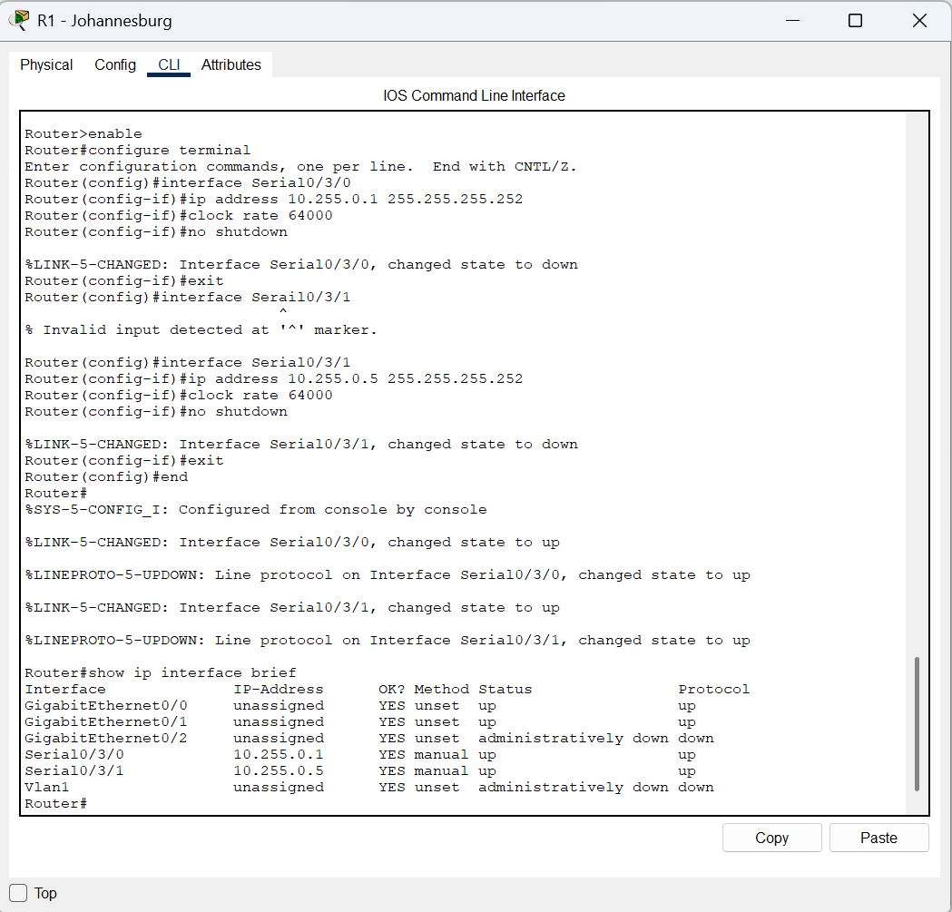
Figure 1: R1 Johannesburg: configuring the serial WAN interface toward Durban.
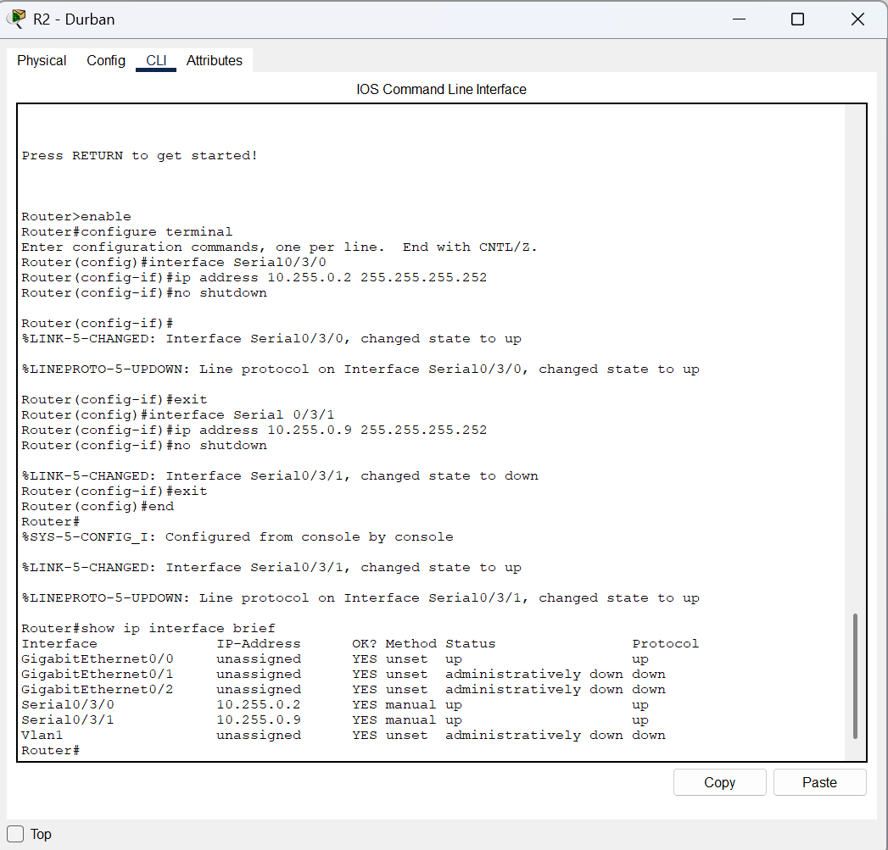
Figure 2: R2 Durban: configuring the serial WAN interface toward Johannesburg.
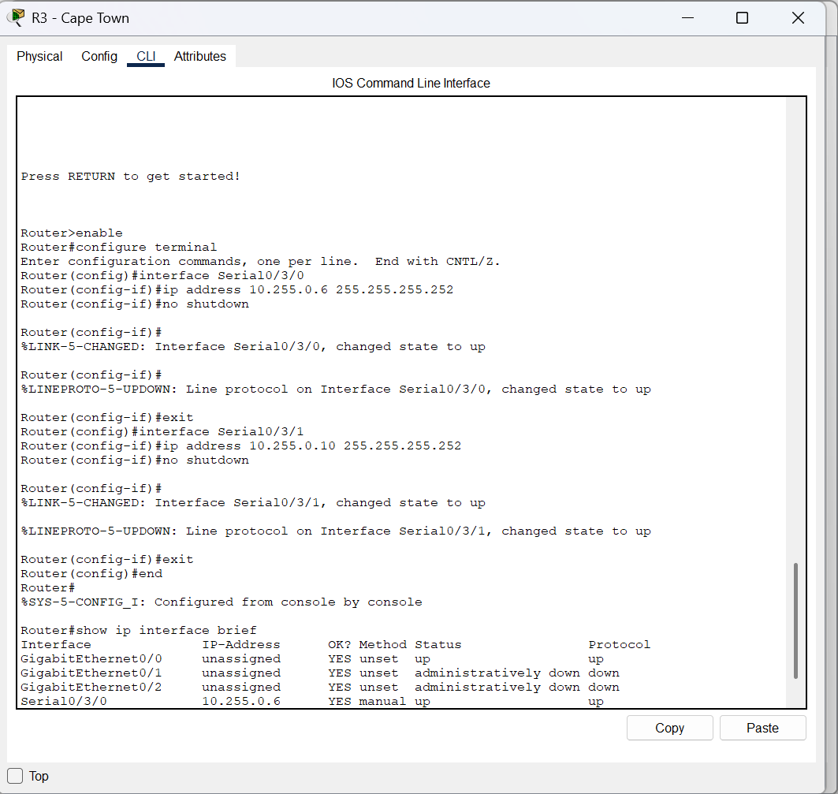
Figure 3: R3 Cape Town: configuring the serial WAN interface toward Johannesburg.
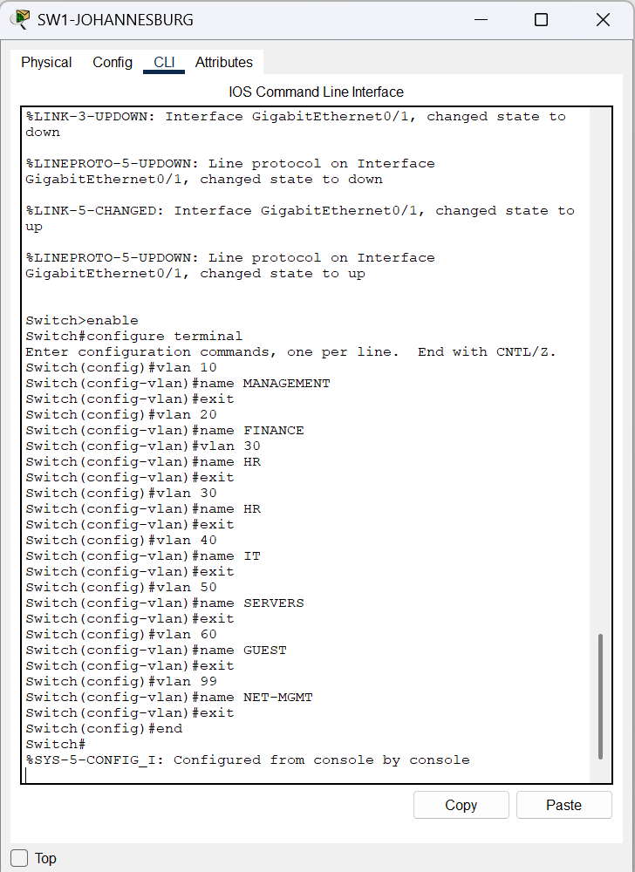
Figure 4: SW1 Johannesburg: creating the branch VLANs.
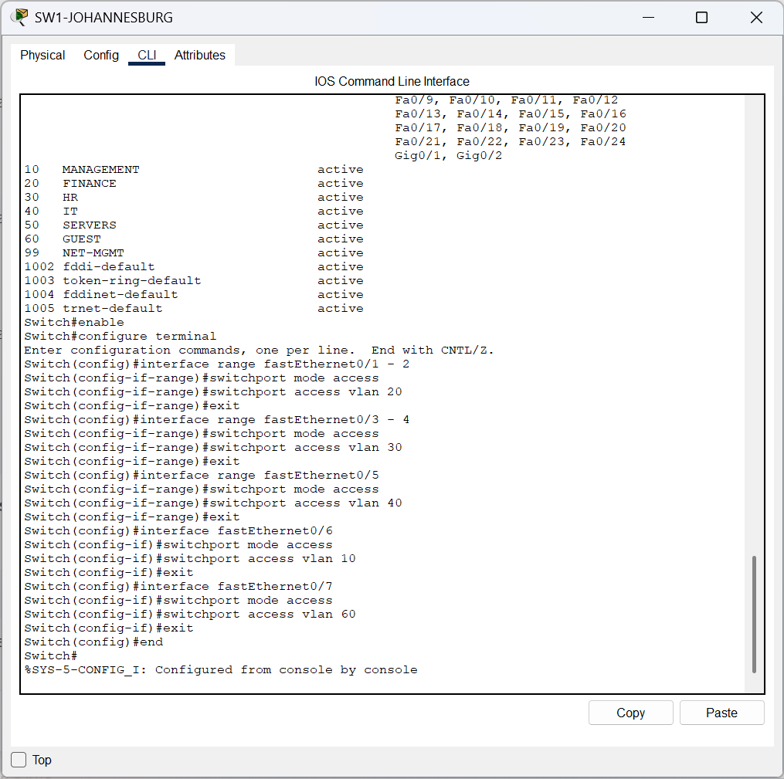
Figure 5: SW1 Johannesburg: checking the VLAN list and active VLAN assignments.
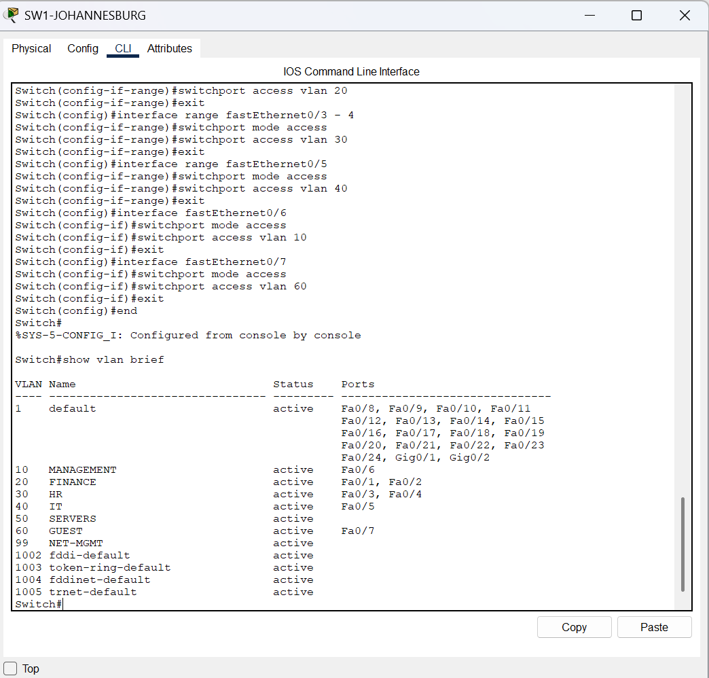
Figure 6: SW1 Johannesburg: assigning access ports to the appropriate VLANs.
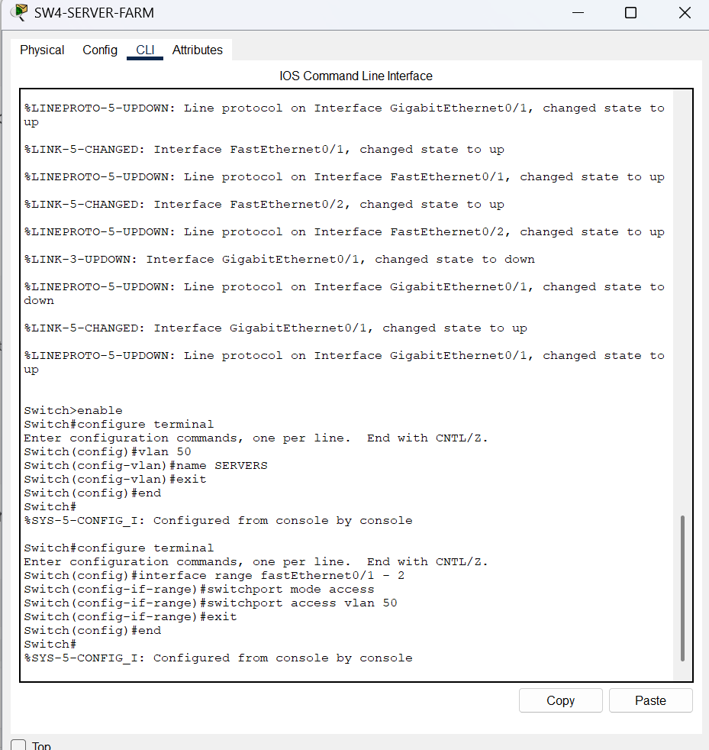
Figure 7: SW4 Server Farm: checking switch interface/link status.
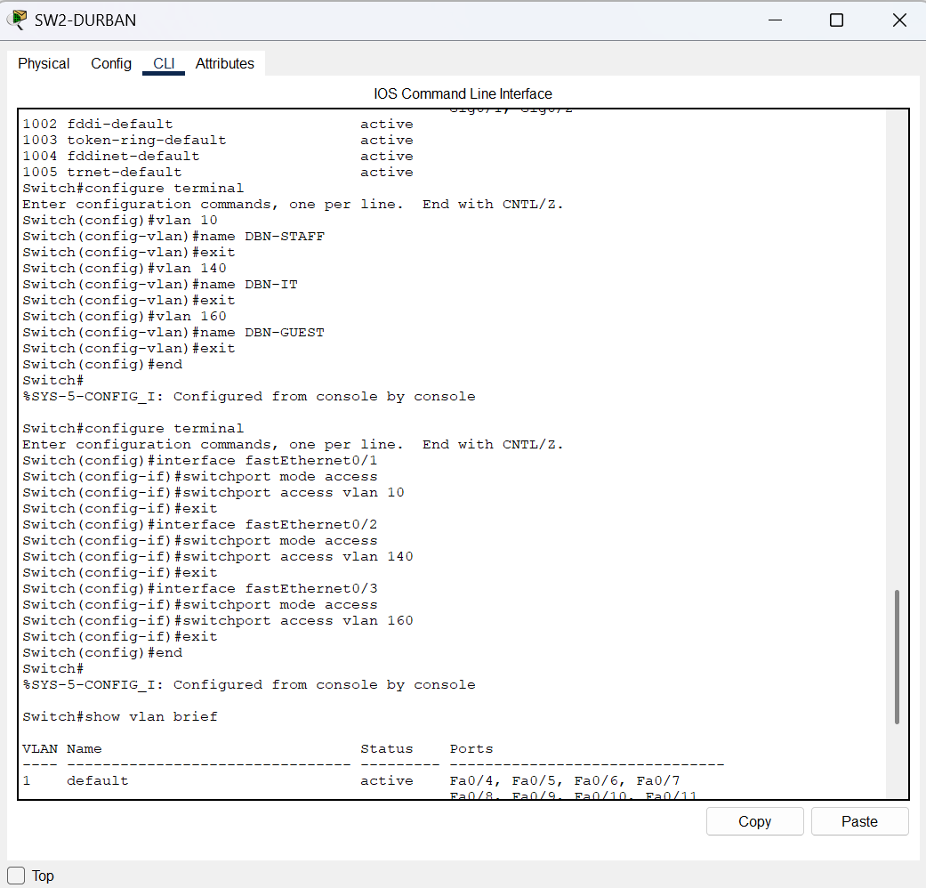
Figure 8: SW2 Durban: viewing the switch VLAN table.
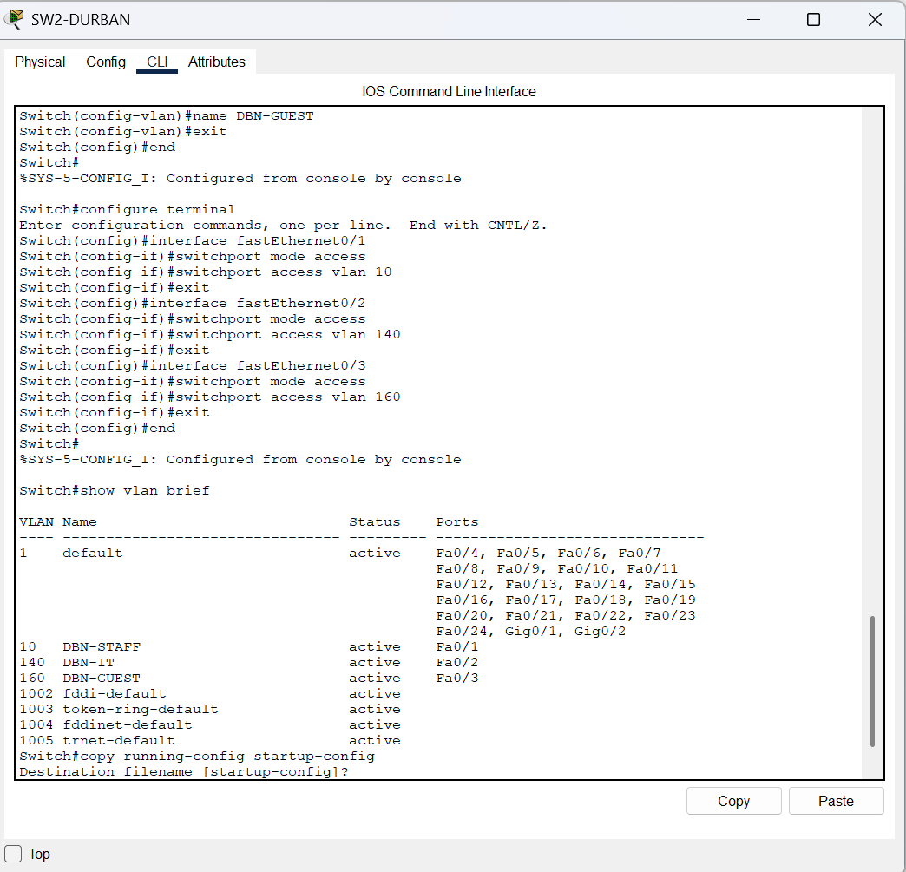
Figure 9: SW2 Durban: completing the Durban guest VLAN configuration.
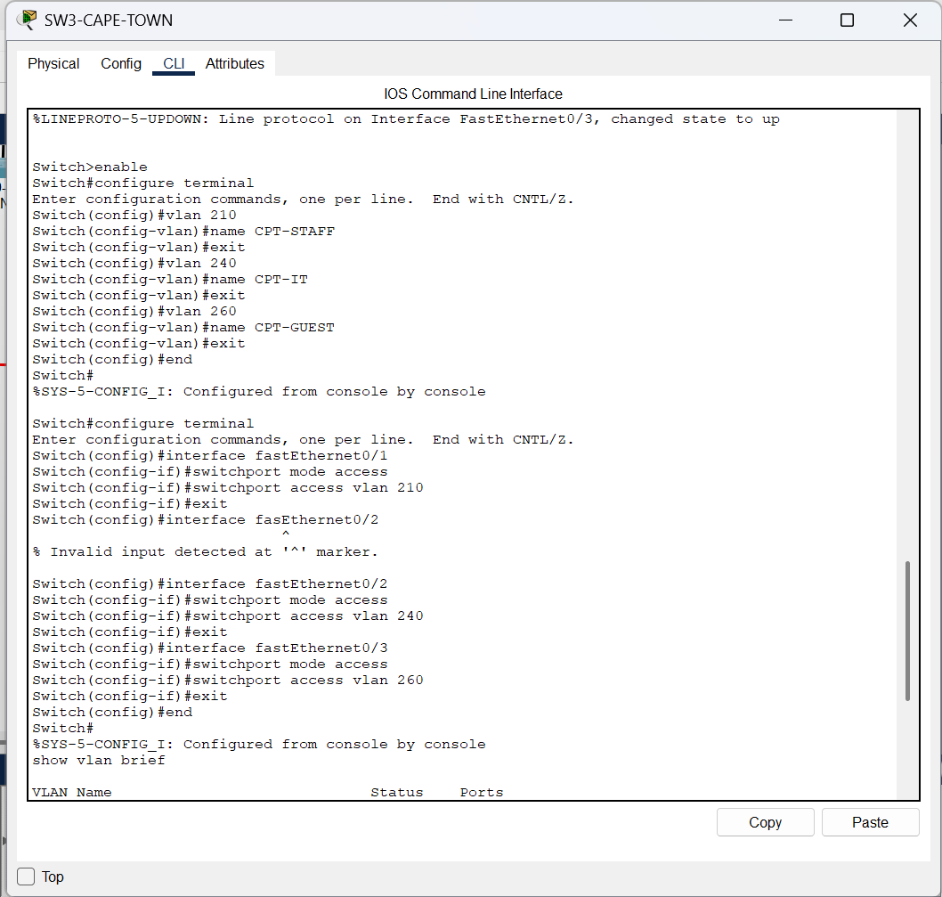
Figure 10: SW3 Cape Town: beginning switch VLAN and port configuration.
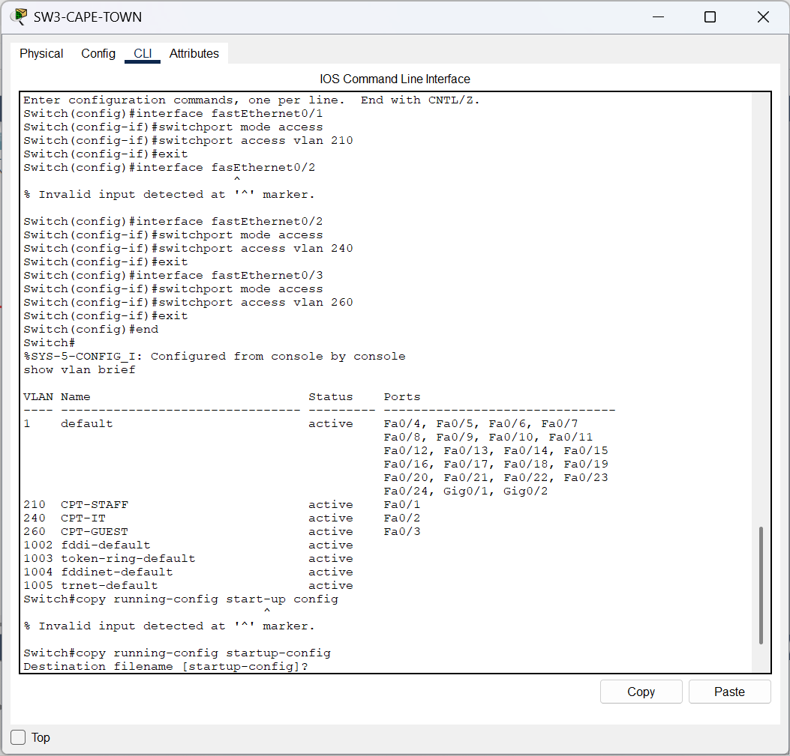
Figure 11: SW3 Cape Town: assigning access ports to staff and other VLANs.
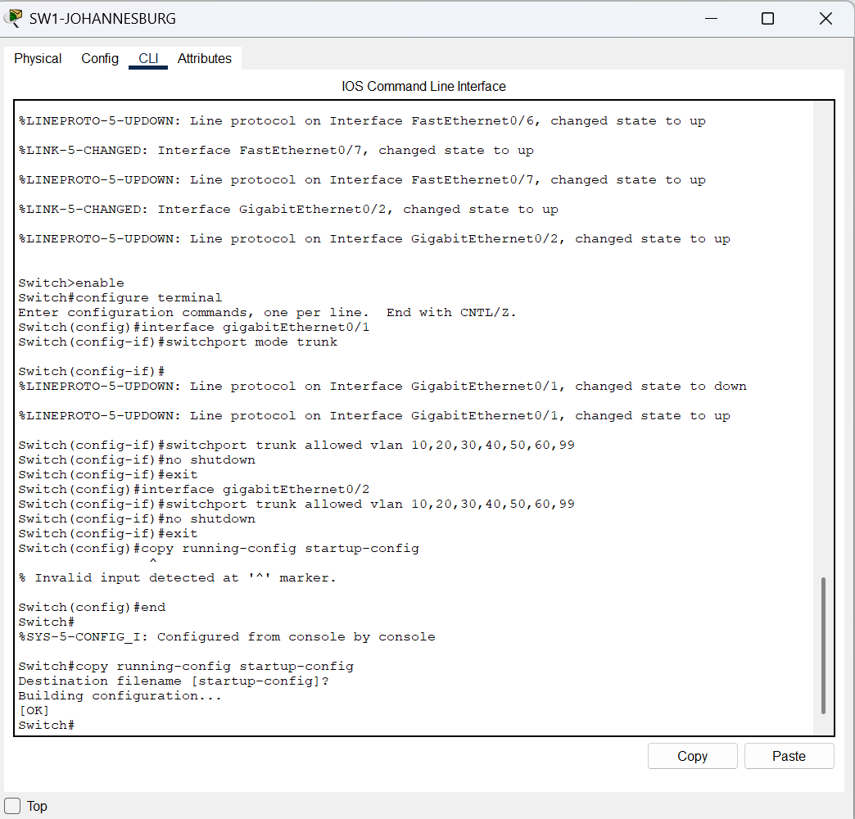
Figure 12: SW1 Johannesburg: checking access-port and server-switch link status.
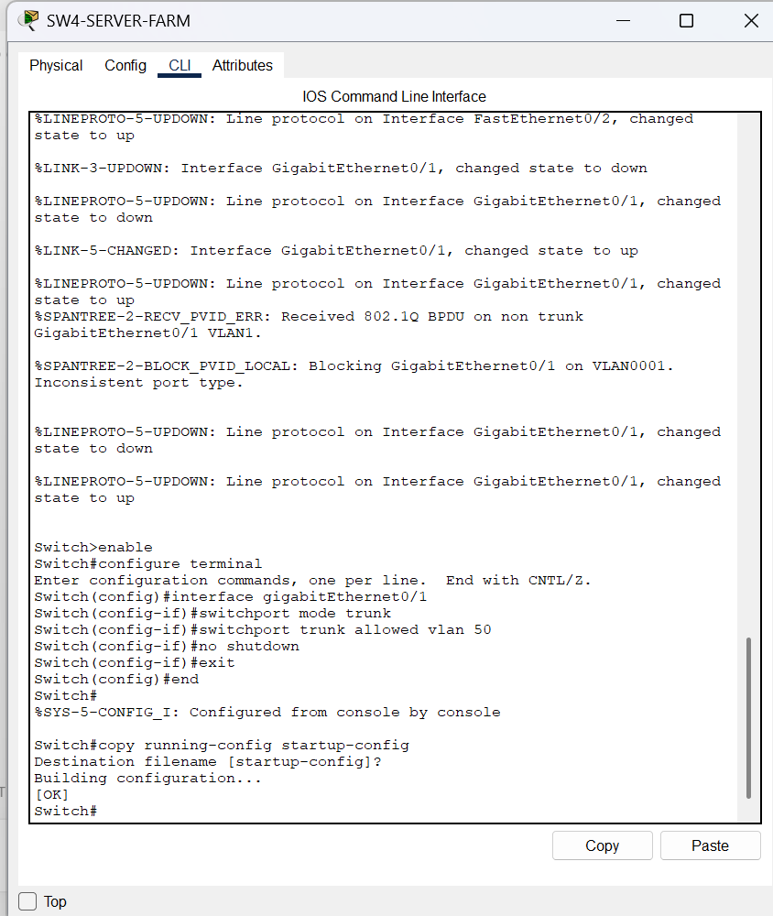
Figure 13: SW4 Server Farm: checking server-farm switch link status.
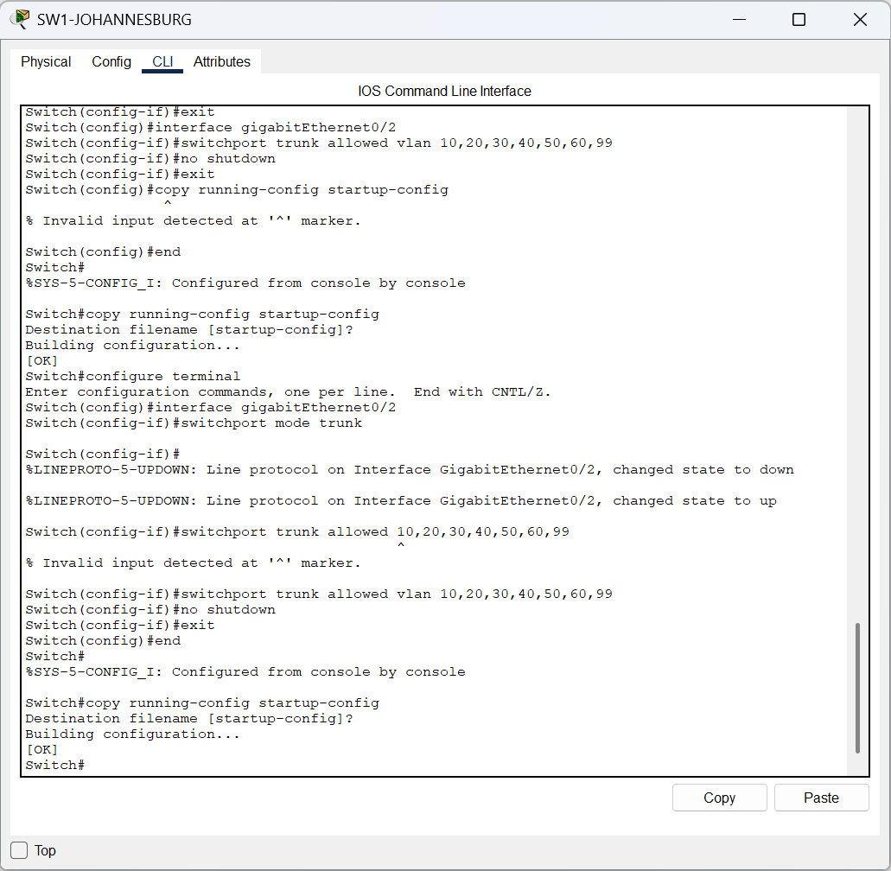
Figure 14: SW1 Johannesburg: configuring the server-switch trunk and allowed VLANs.
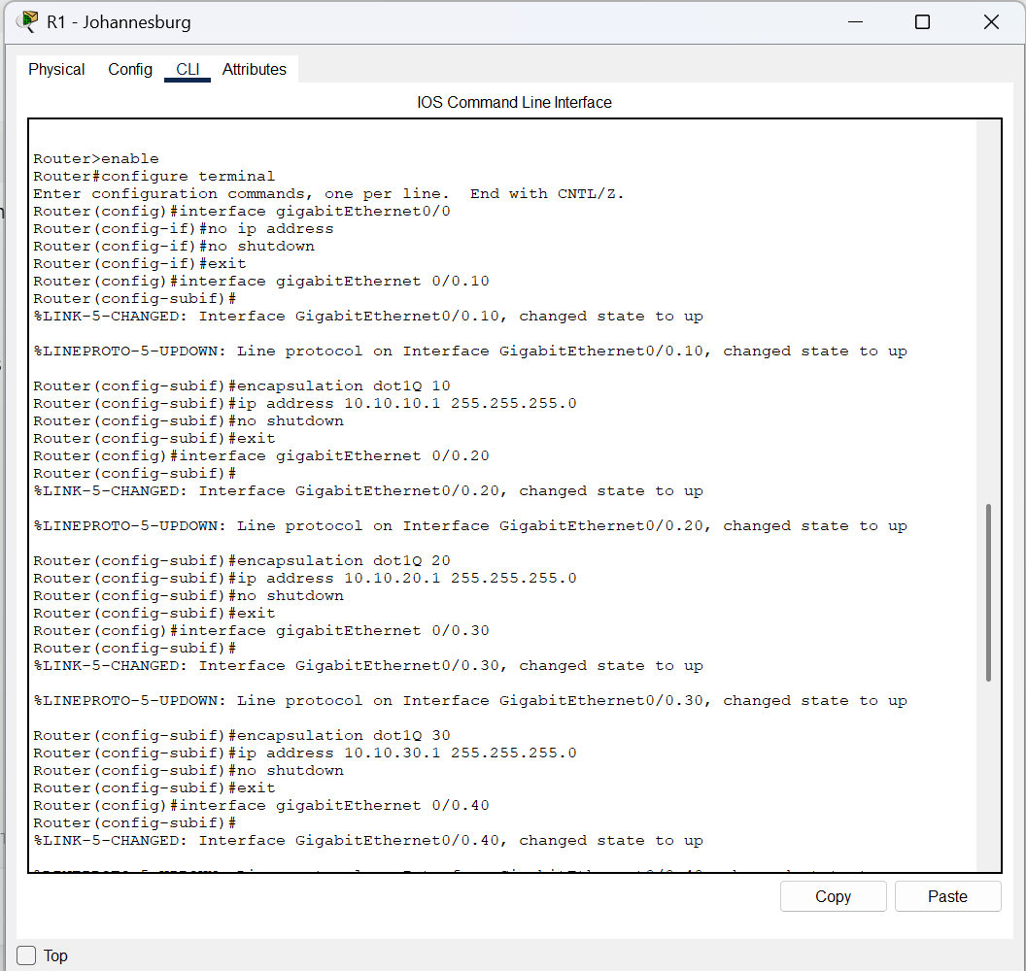
Figure 15: R1 Johannesburg: configuring the main LAN interface for VLAN gateways.
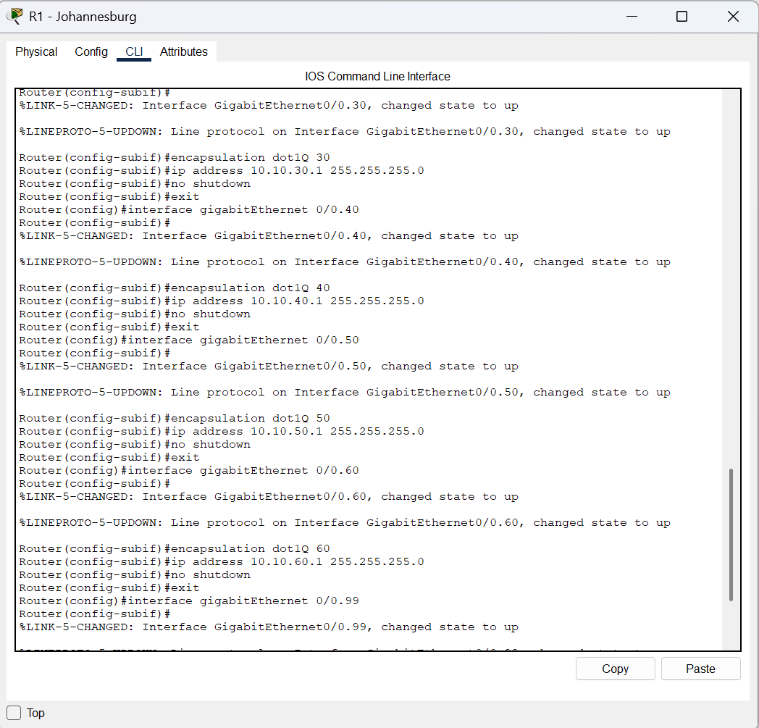
Figure 16: R1 Johannesburg: configuring the HR VLAN subinterface and gateway.
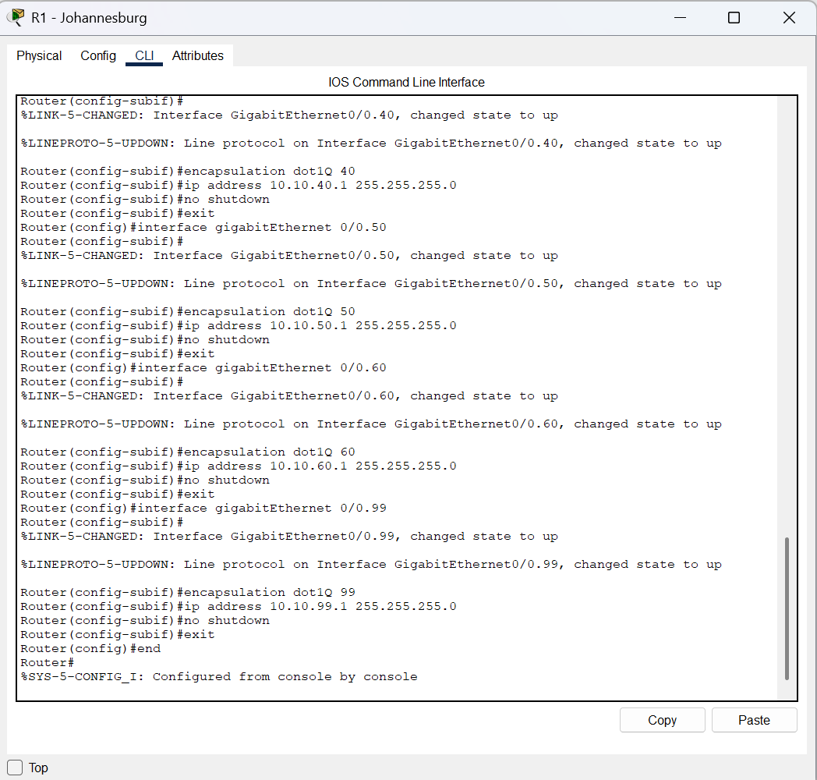
Figure 17: R1 Johannesburg: configuring the IT VLAN subinterface and gateway.
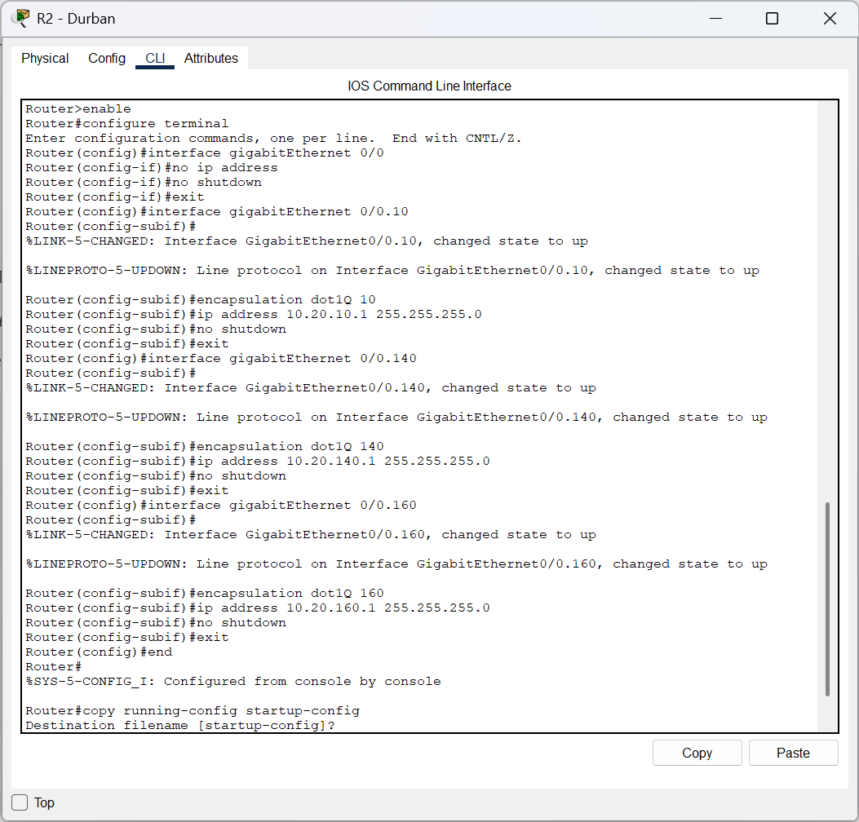
Figure 18: R2 Durban: configuring the Durban LAN/VLAN gateway interfaces.
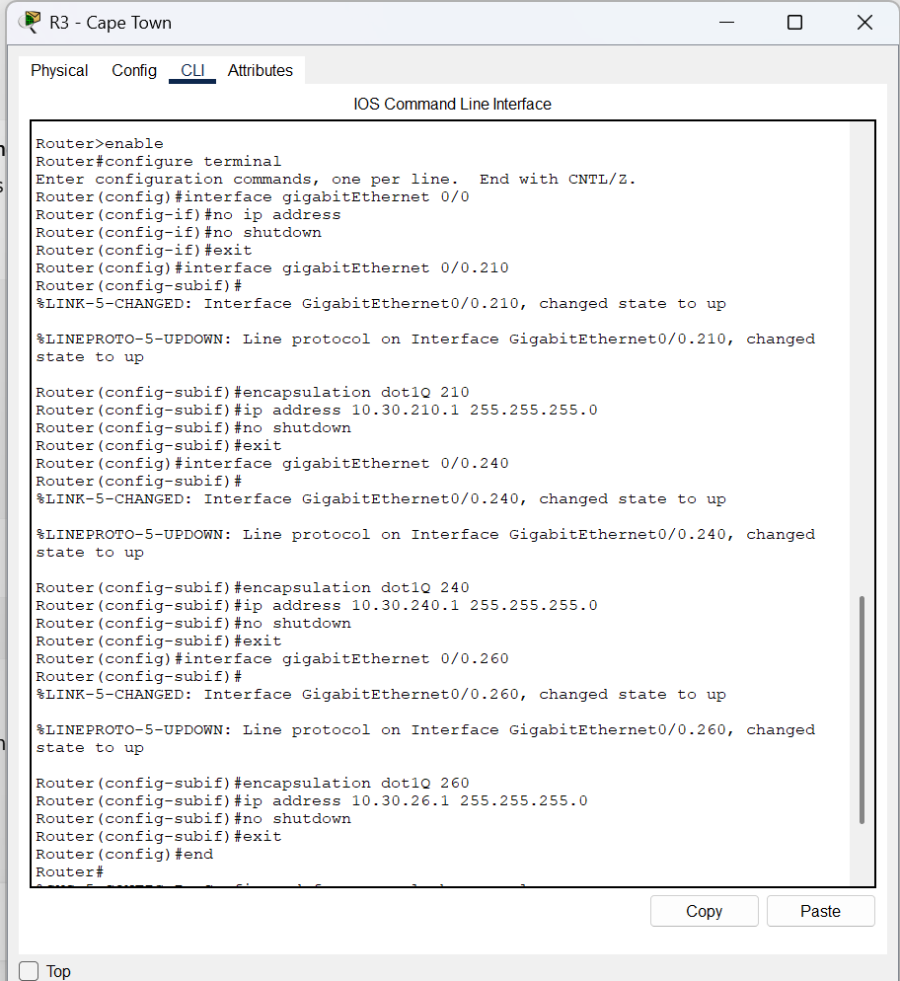
Figure 19: R3 Cape Town: configuring the Cape Town LAN/VLAN gateway interfaces.
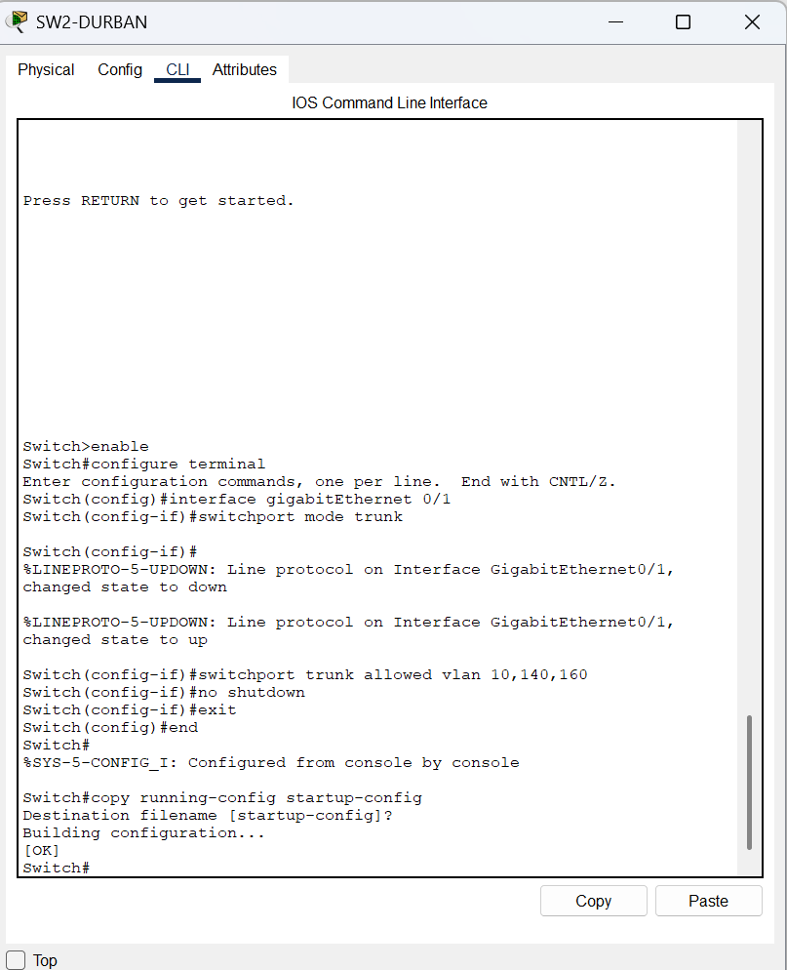
Figure 20: SW2 Durban: configuring switch access ports and VLAN membership.
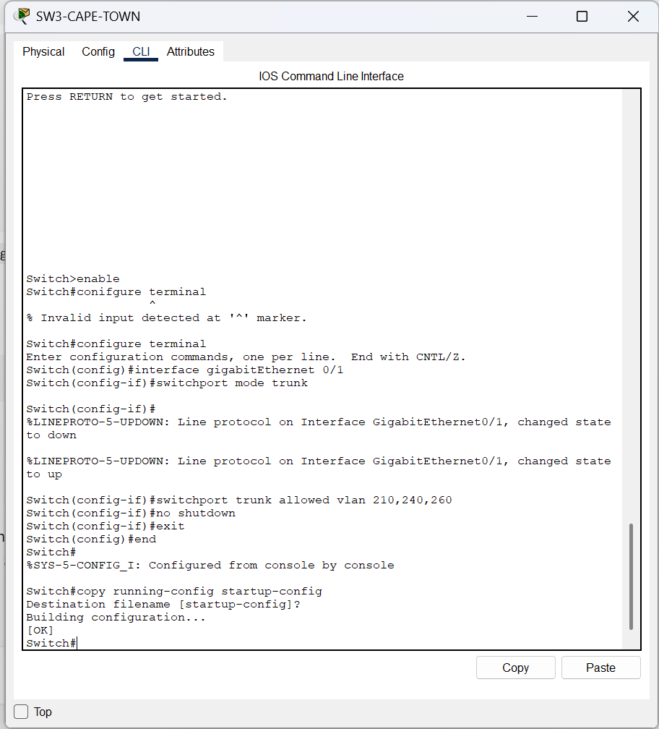
Figure 21: Switch configuration: continuing branch VLAN and access-port setup.
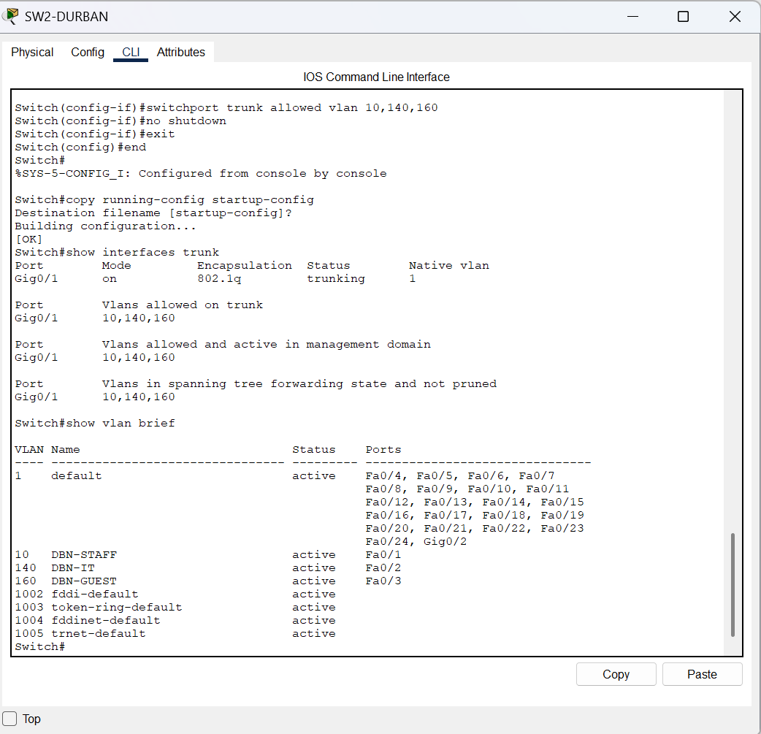
Figure 22: Switch configuration: verifying VLAN assignments and port membership.
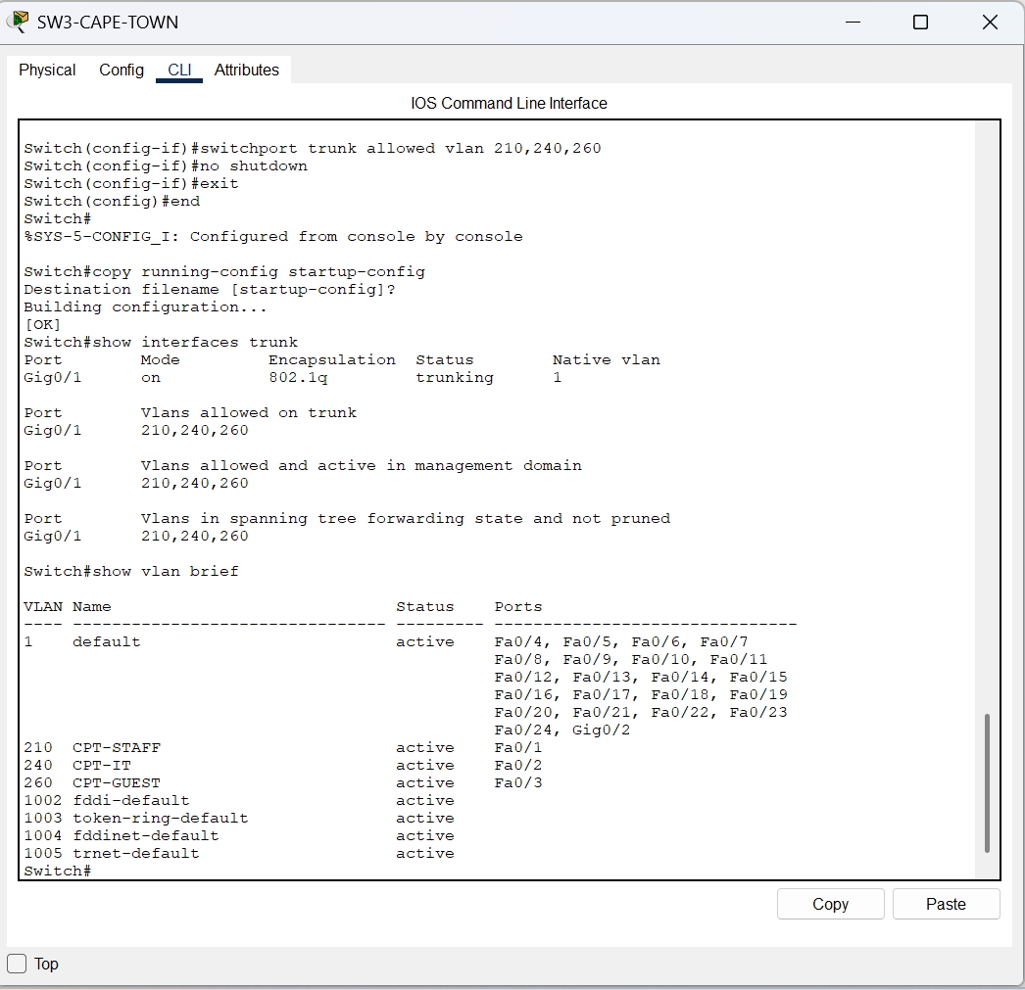
Figure 23: Switch configuration: configuring trunk links between switch and router.
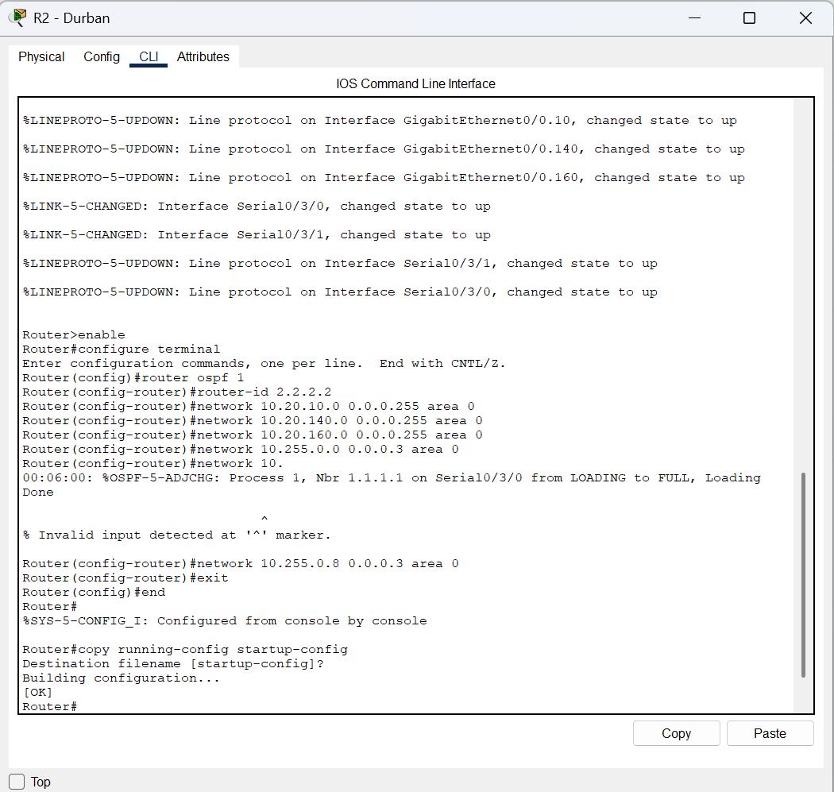
Figure 24: Switch configuration: allowing the required VLANs across a trunk.
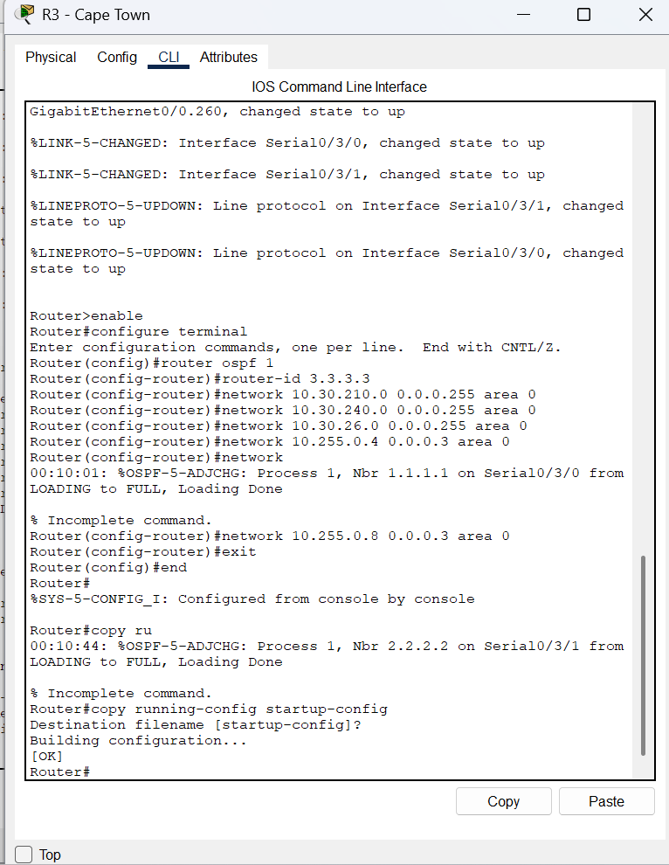
Figure 25: Router configuration: continuing interface and VLAN gateway setup.
Figure 26: Router configuration: additional interface configuration evidence.
Figure 27: Router configuration: additional interface configuration evidence.
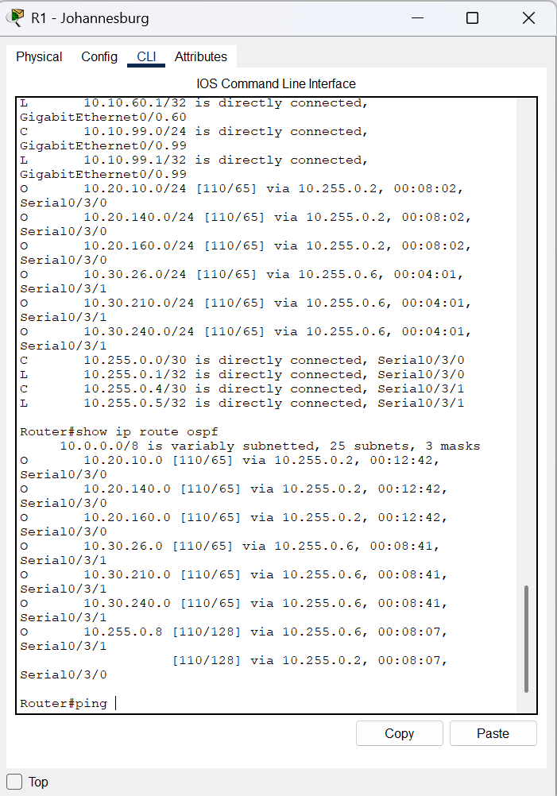
Figure 28: Router configuration: configuring branch interface addressing.
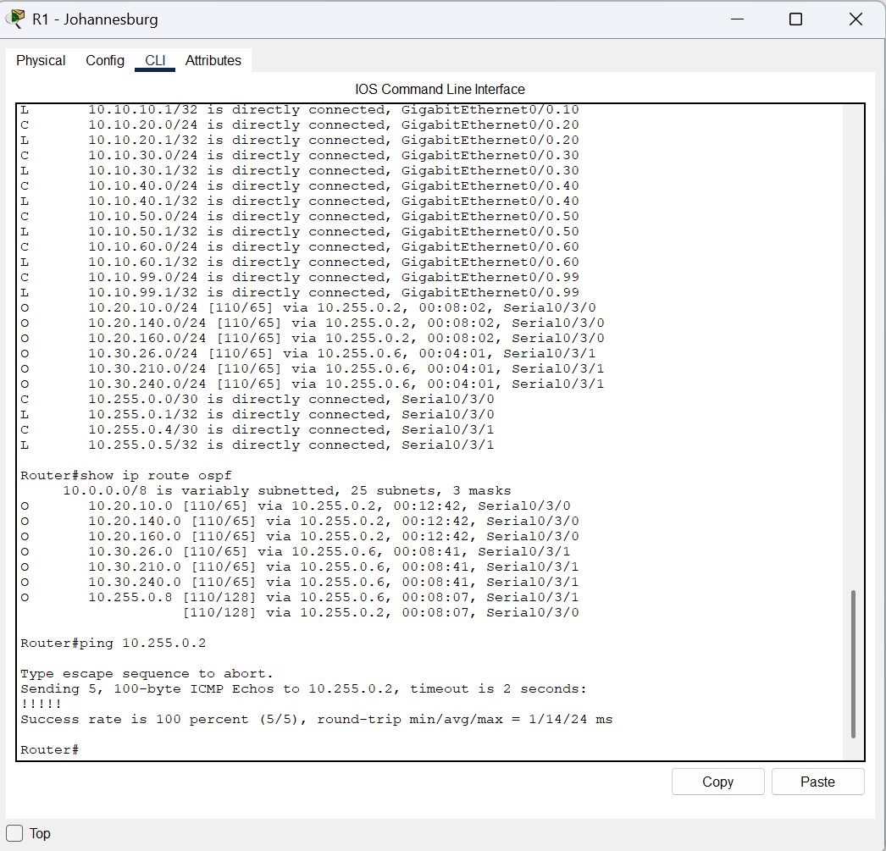
Figure 29: Router configuration: configuring a VLAN subinterface and gateway.
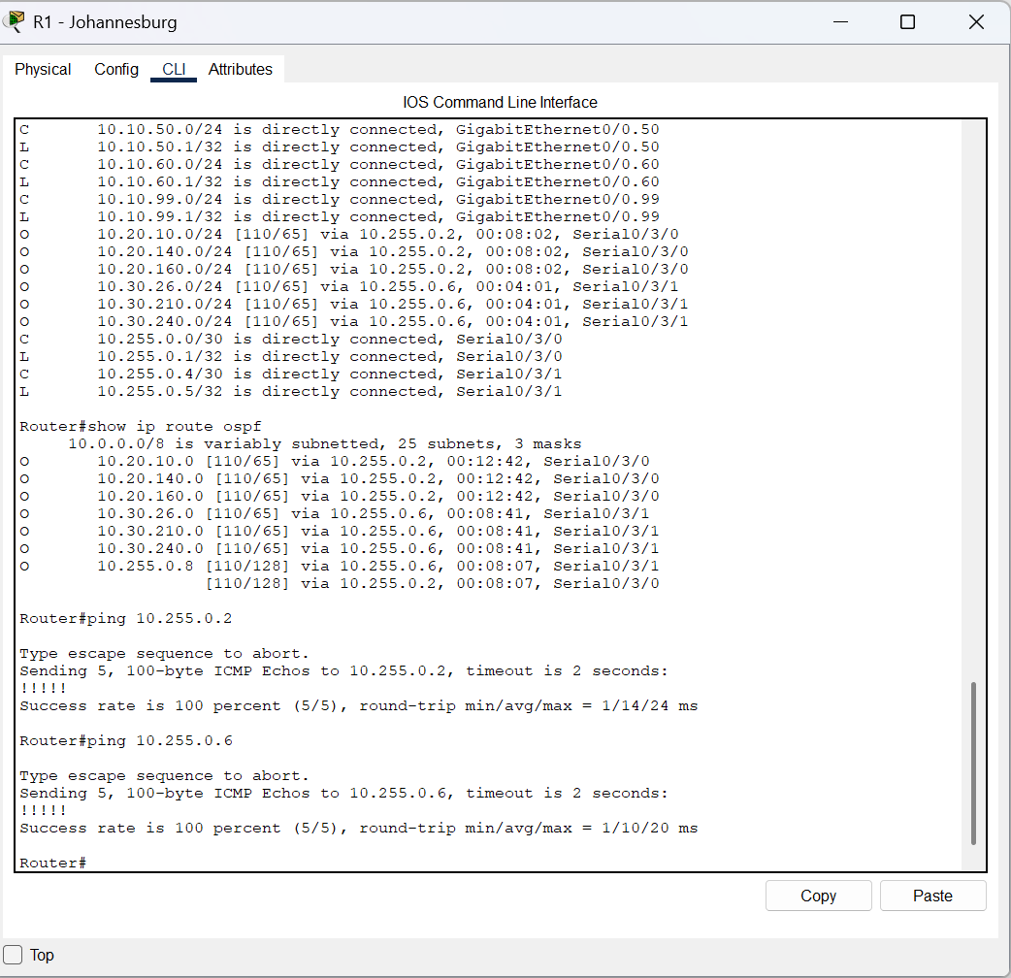
Figure 30: Router configuration: configuring another VLAN subinterface and gateway.
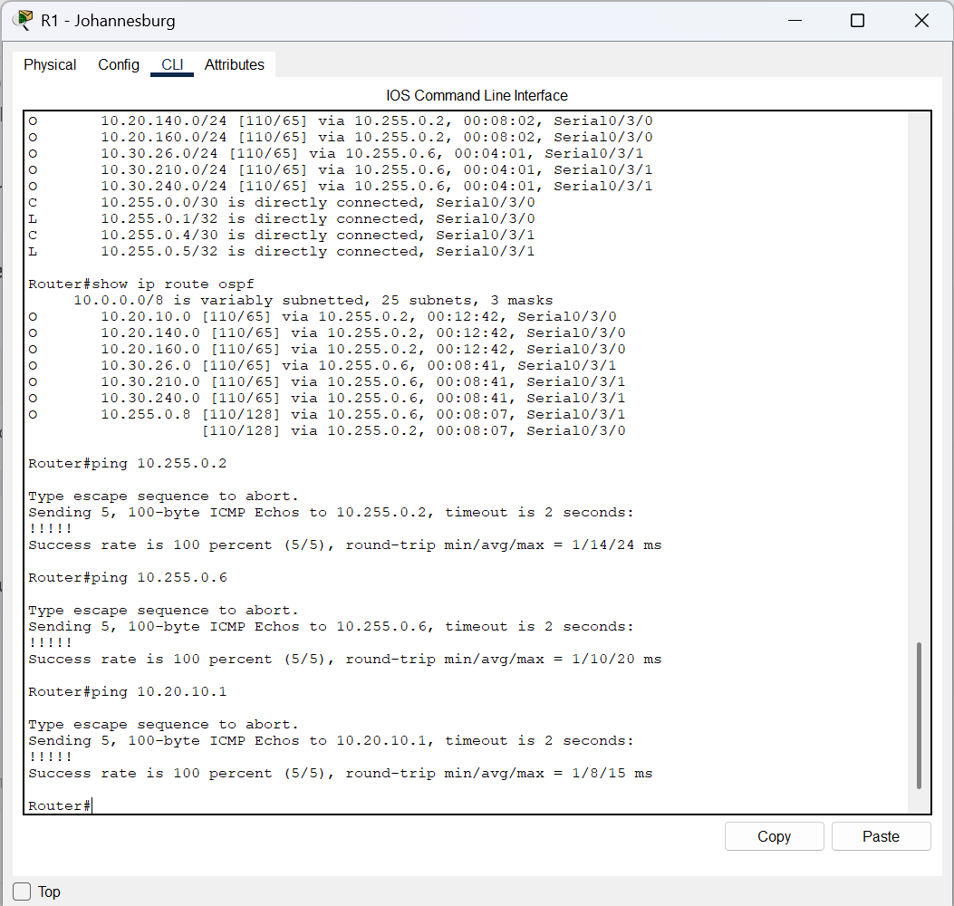
Figure 31: Router configuration: checking interface configuration and status.
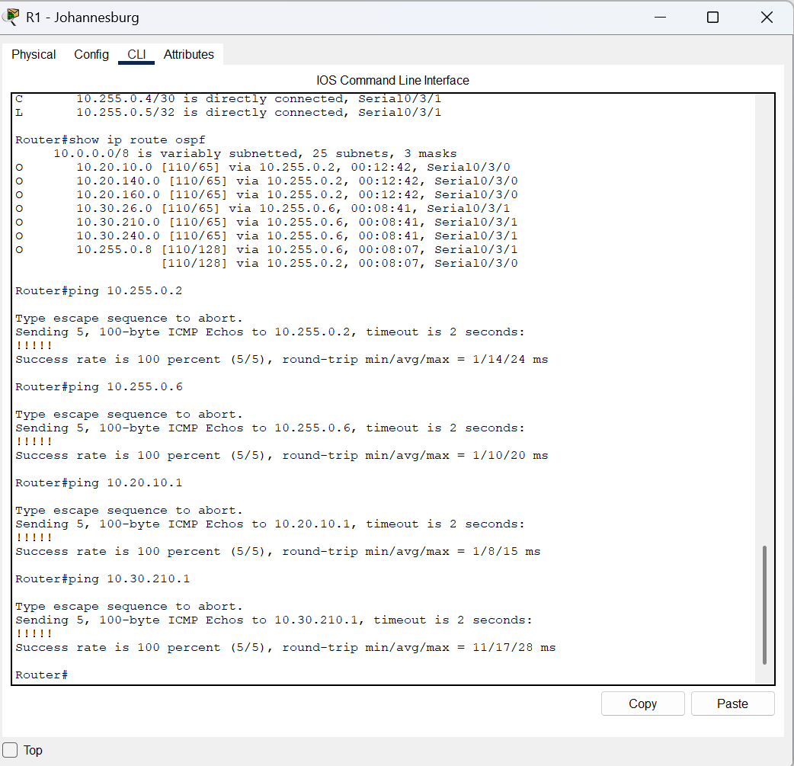
Figure 32: Router configuration: setting up routing between branch networks.
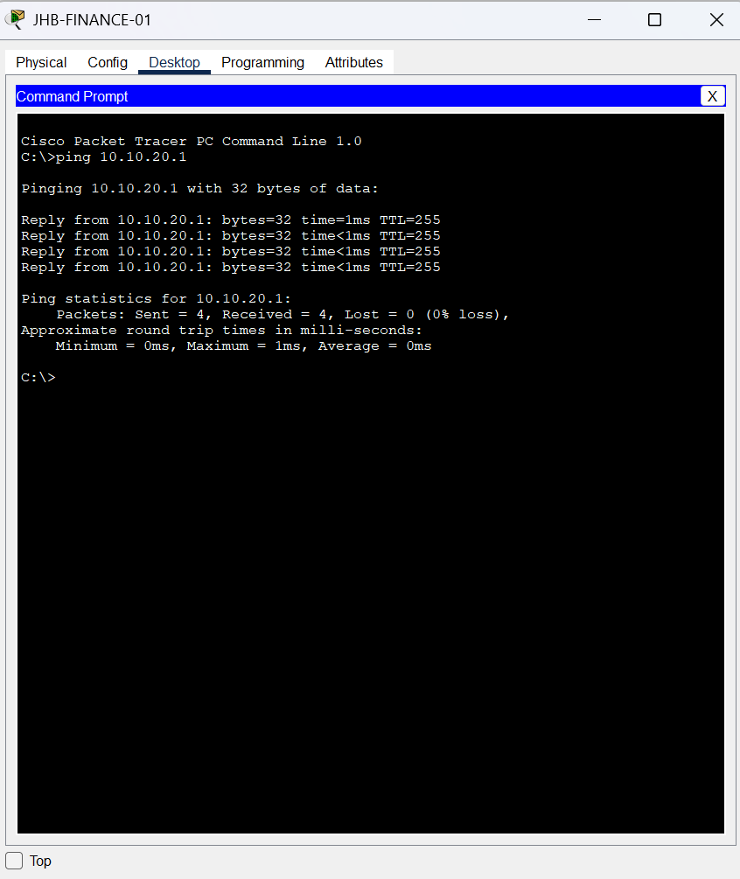
Figure 33: Router configuration: configuring WAN addressing and connectivity.
Figure 34: Router configuration: continuing WAN/interface configuration.
Figure 35: Router configuration: configuring routing and network advertisements.
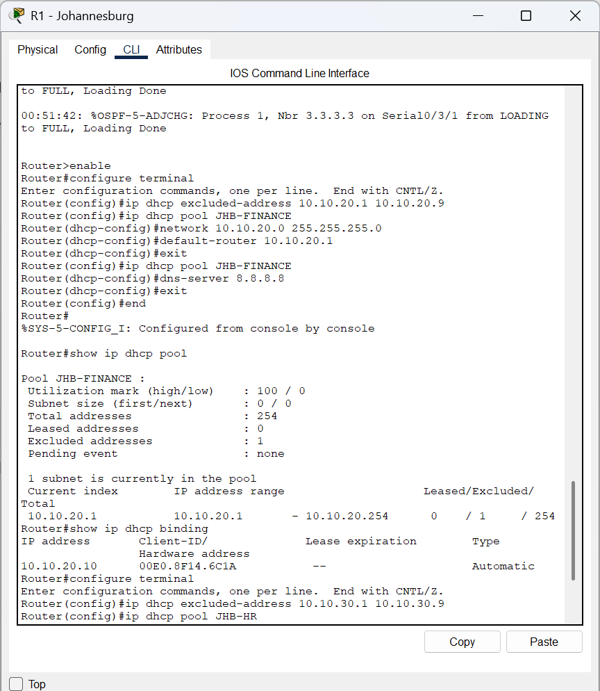
Figure 36: DHCP configuration: creating or updating a branch address pool.
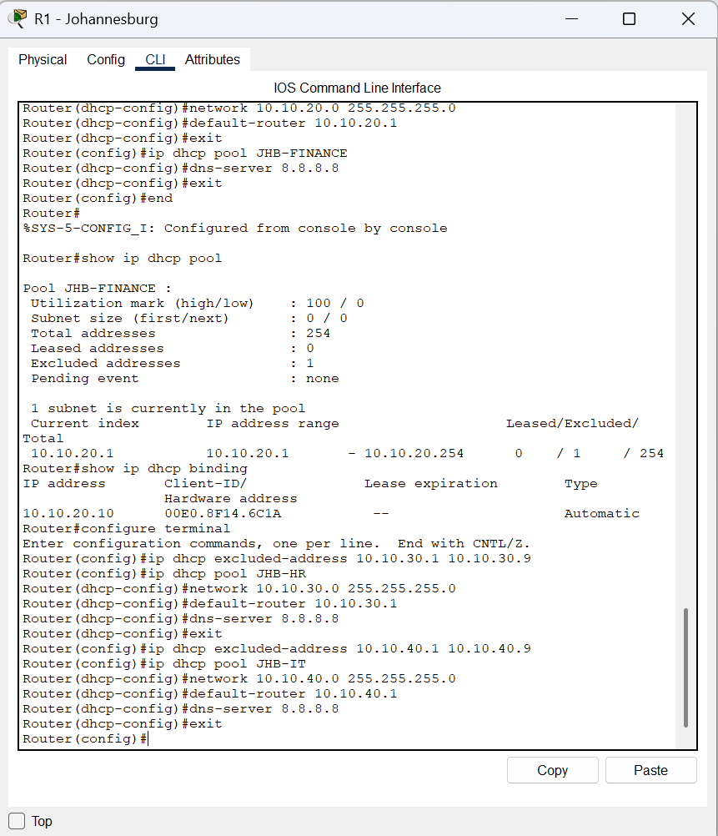
Figure 37: DHCP configuration: setting the pool network and default gateway.
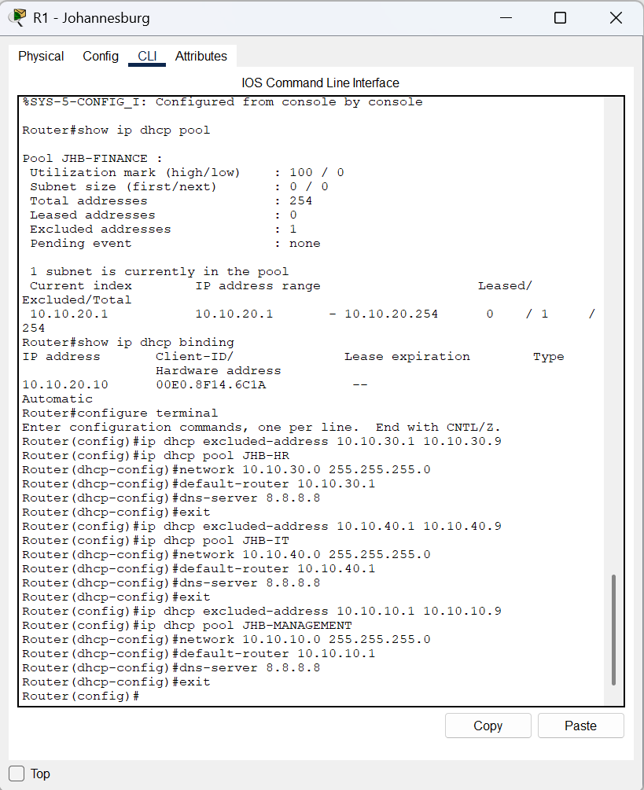
Figure 38: DHCP configuration: setting DNS and excluding reserved addresses.
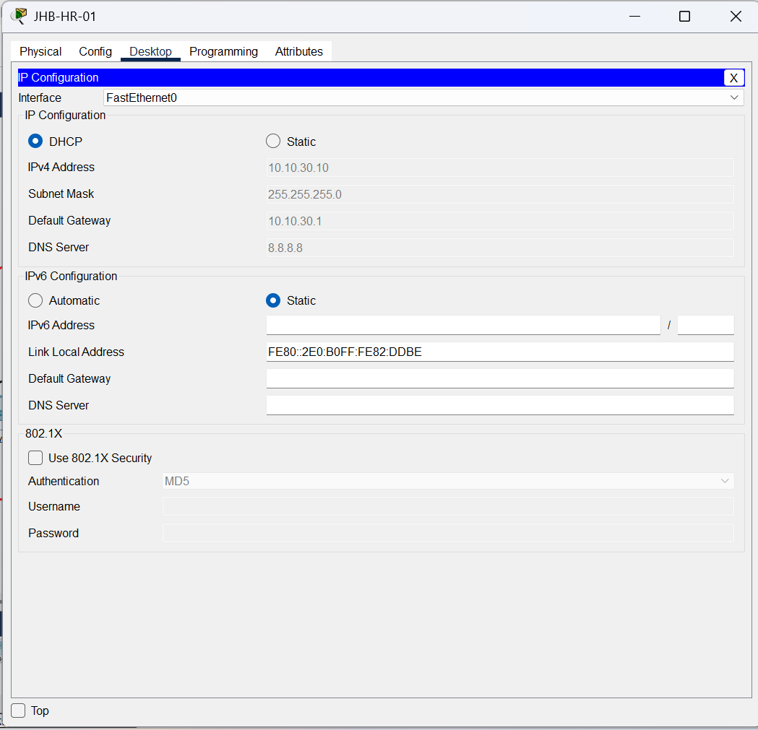
Figure 39: DHCP verification: checking the configured DHCP pools.
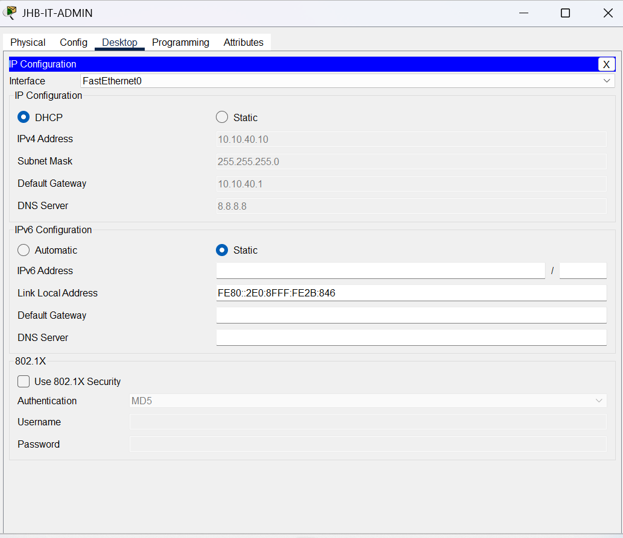
Figure 40: DHCP verification: checking client address bindings.
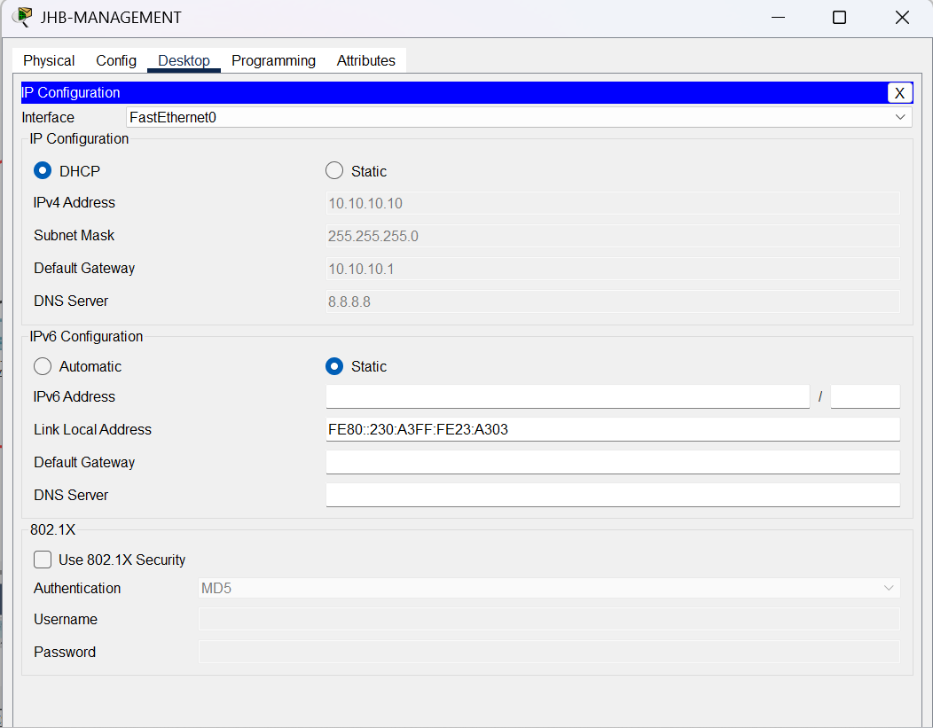
Figure 41: OSPF configuration: enabling routing for the branch networks.
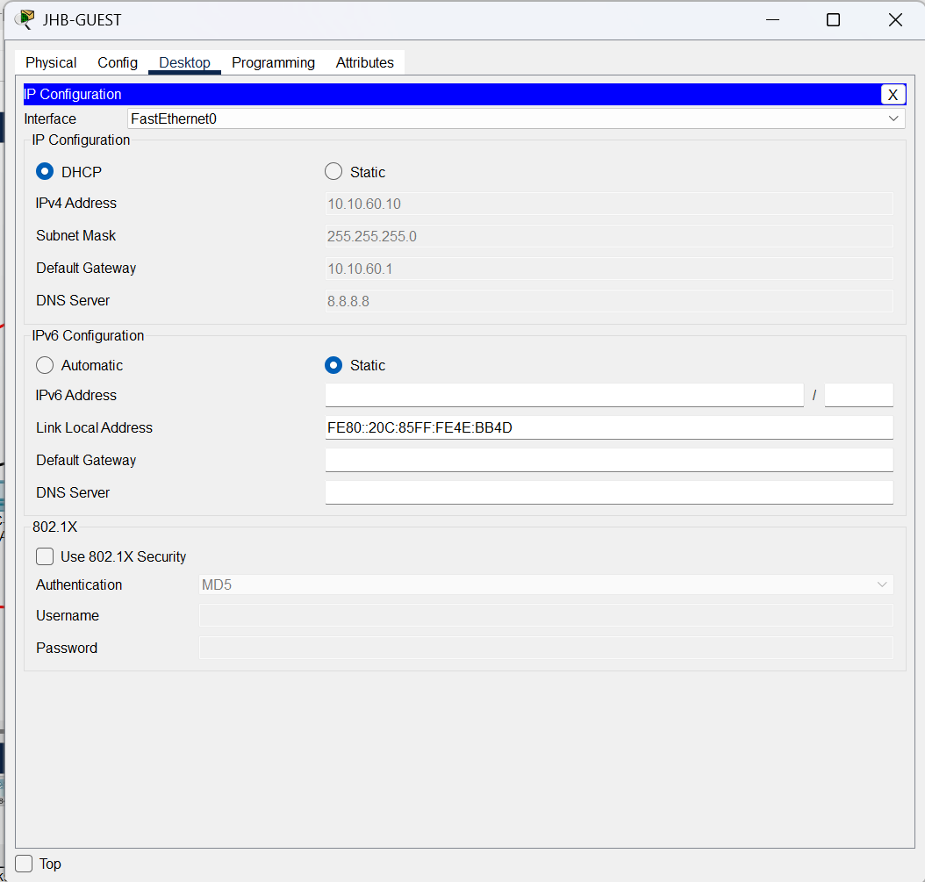
Figure 42: OSPF configuration: advertising connected networks in the routing area.
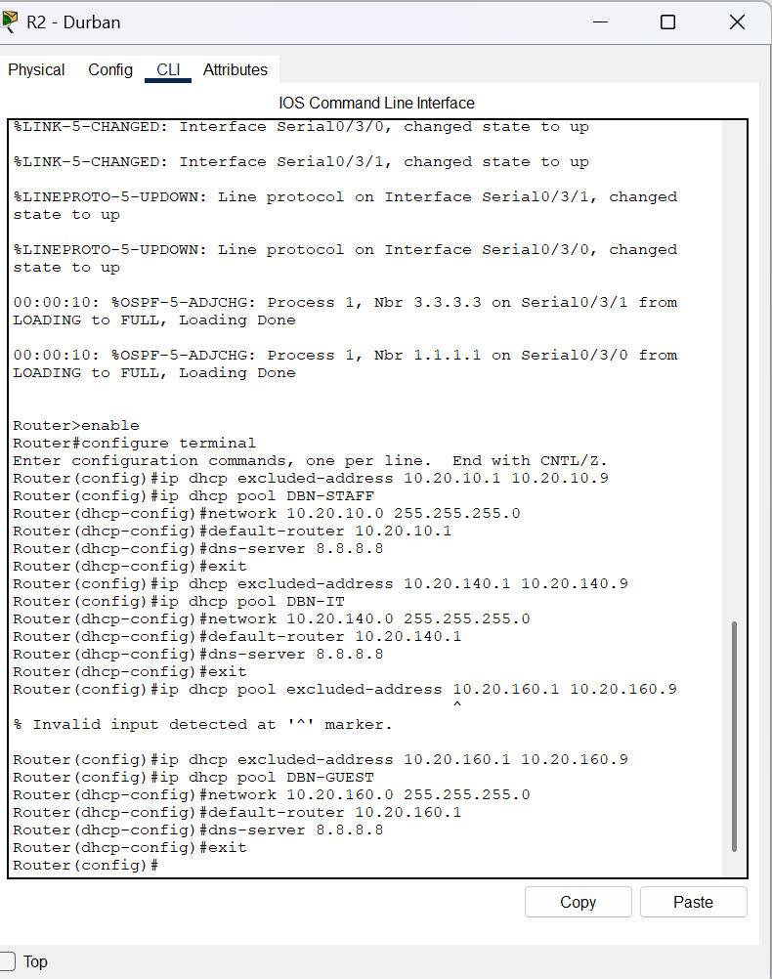
Figure 43: OSPF verification: checking OSPF neighbours.
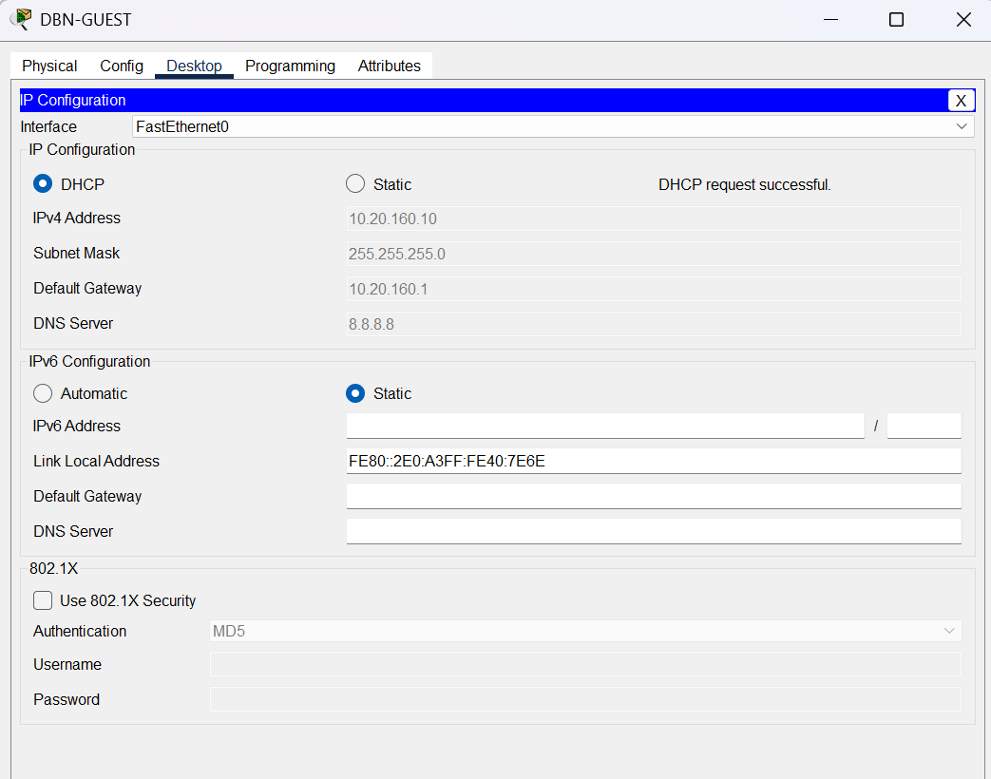
Figure 44: OSPF verification: confirming routing neighbours and learned routes.
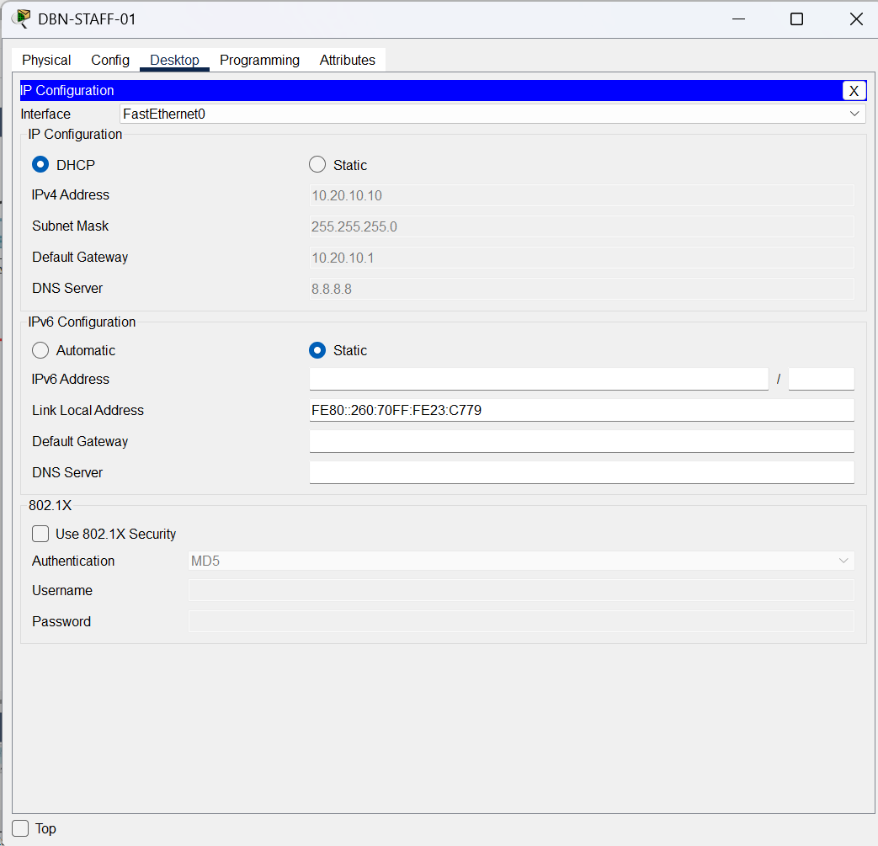
Figure 45: Routing verification: checking the IP routing table.
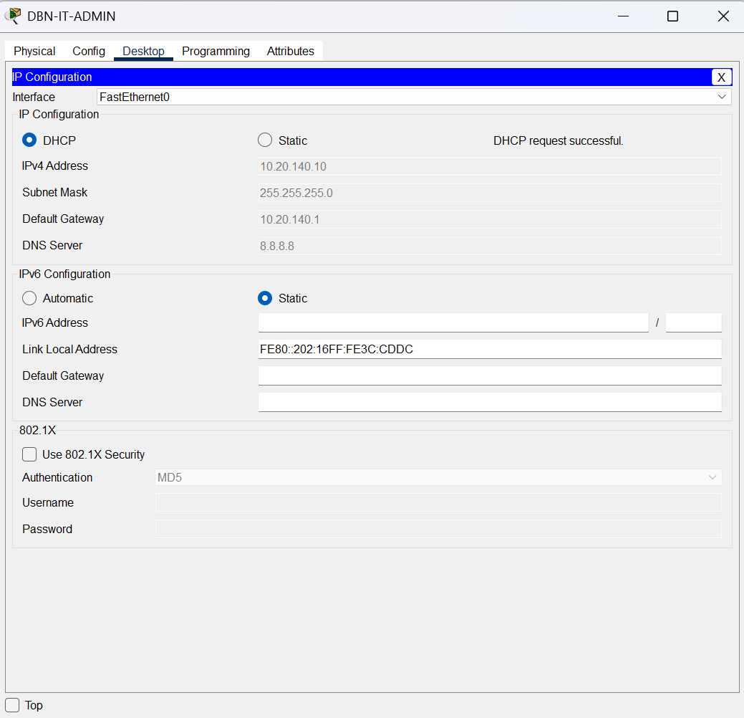
Figure 46: Routing verification: checking routes learned through OSPF.
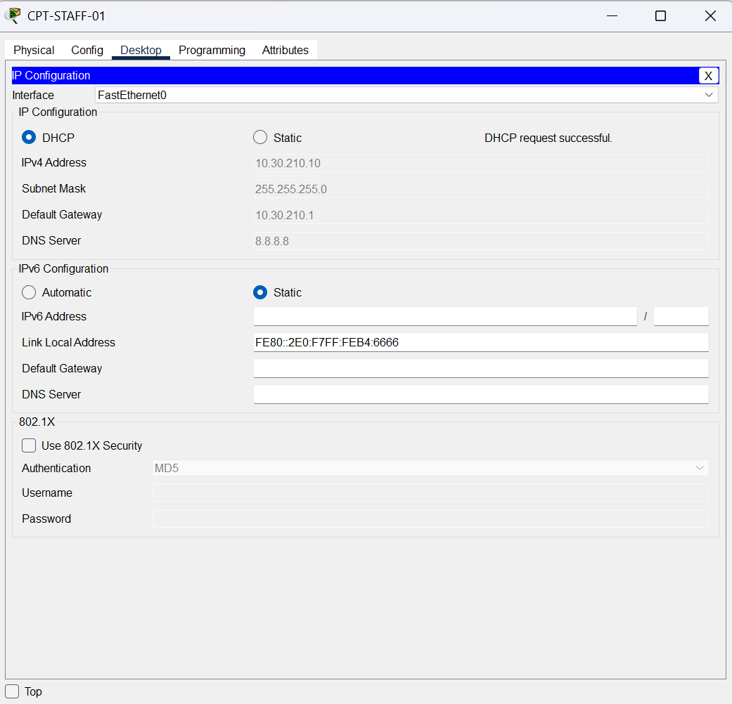
Figure 47: Guest security: configuring the Johannesburg guest access-control list.
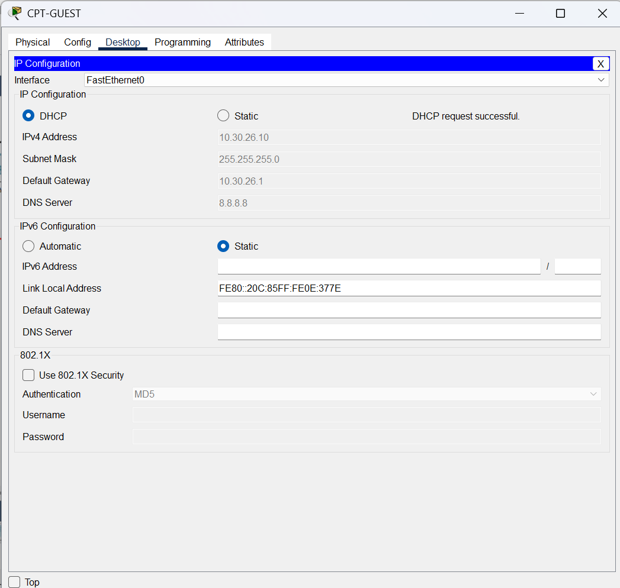
Figure 48: Guest security: applying the guest ACL to the relevant router interface.
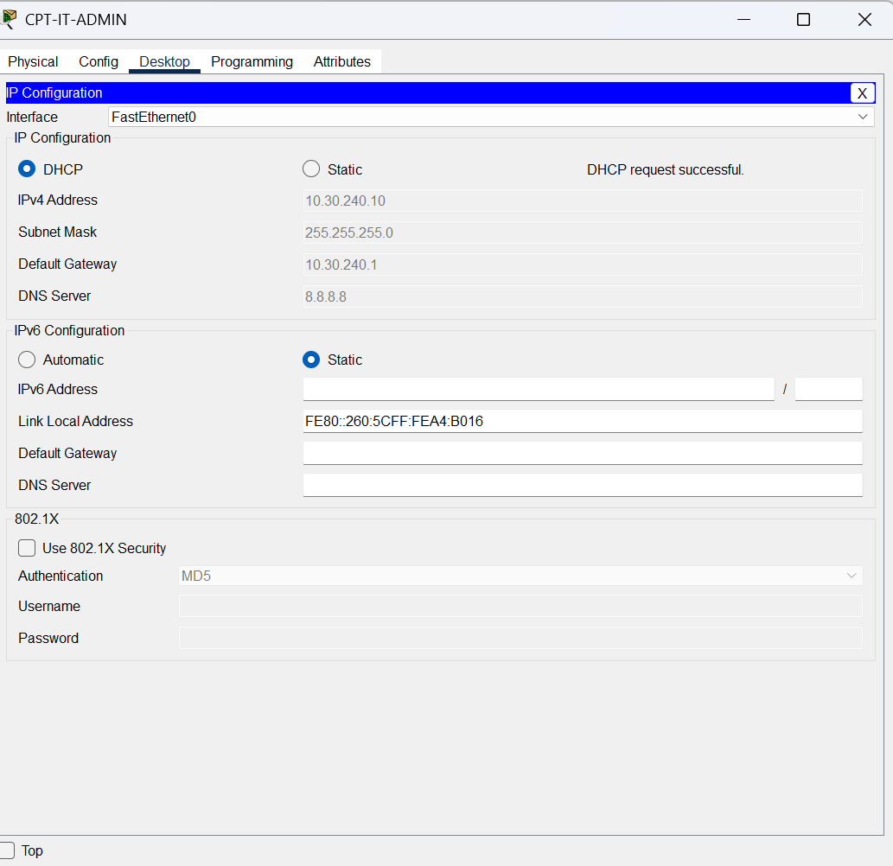
Figure 49: Guest security: configuring the Durban guest access-control list.
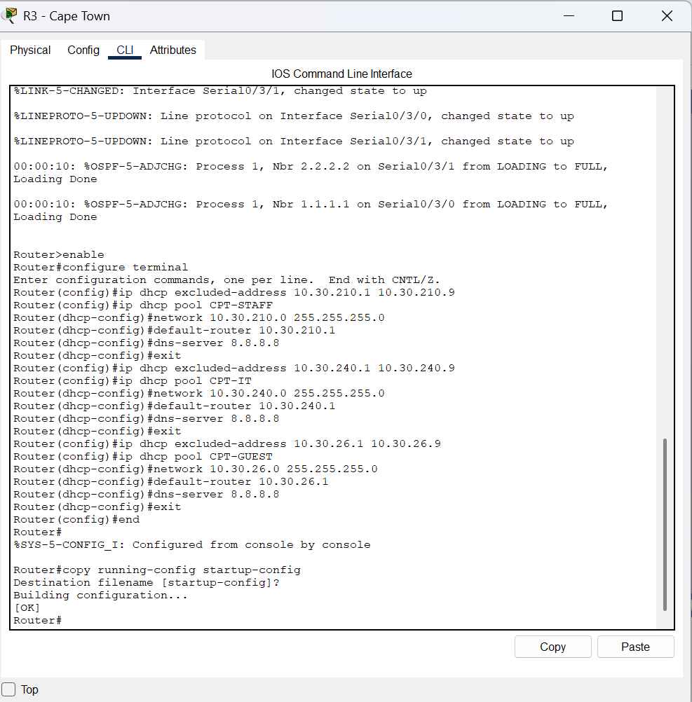
Figure 50: Guest security: applying the Durban guest ACL to the guest interface.
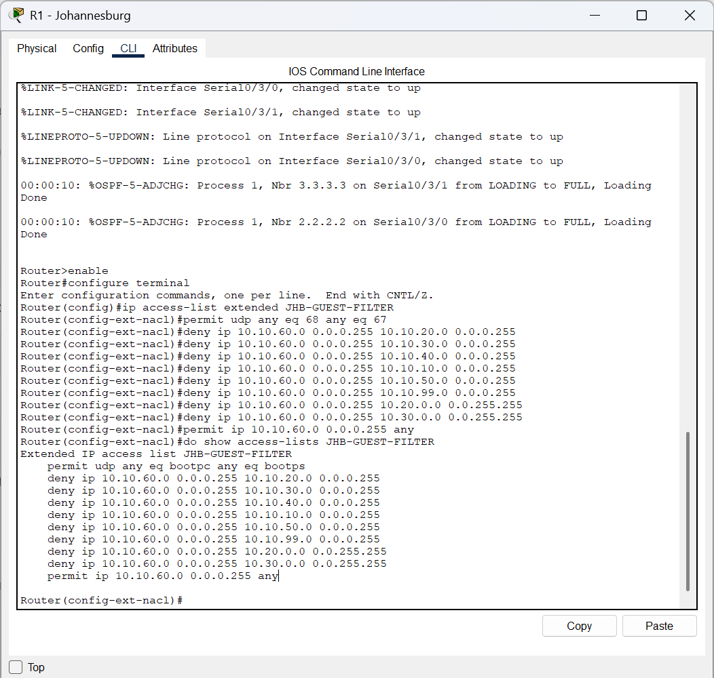
Figure 51: Guest security: configuring the Cape Town guest access-control list.
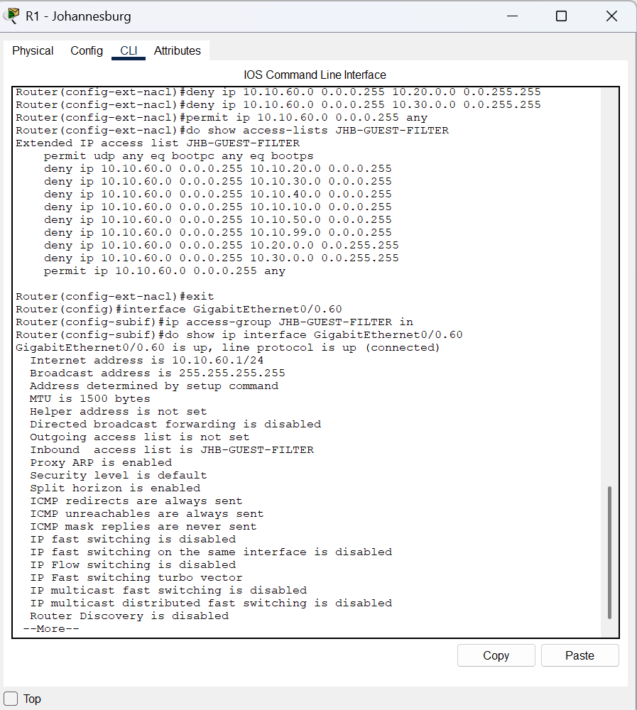
Figure 52: Guest security: applying the Cape Town guest ACL to the guest interface.
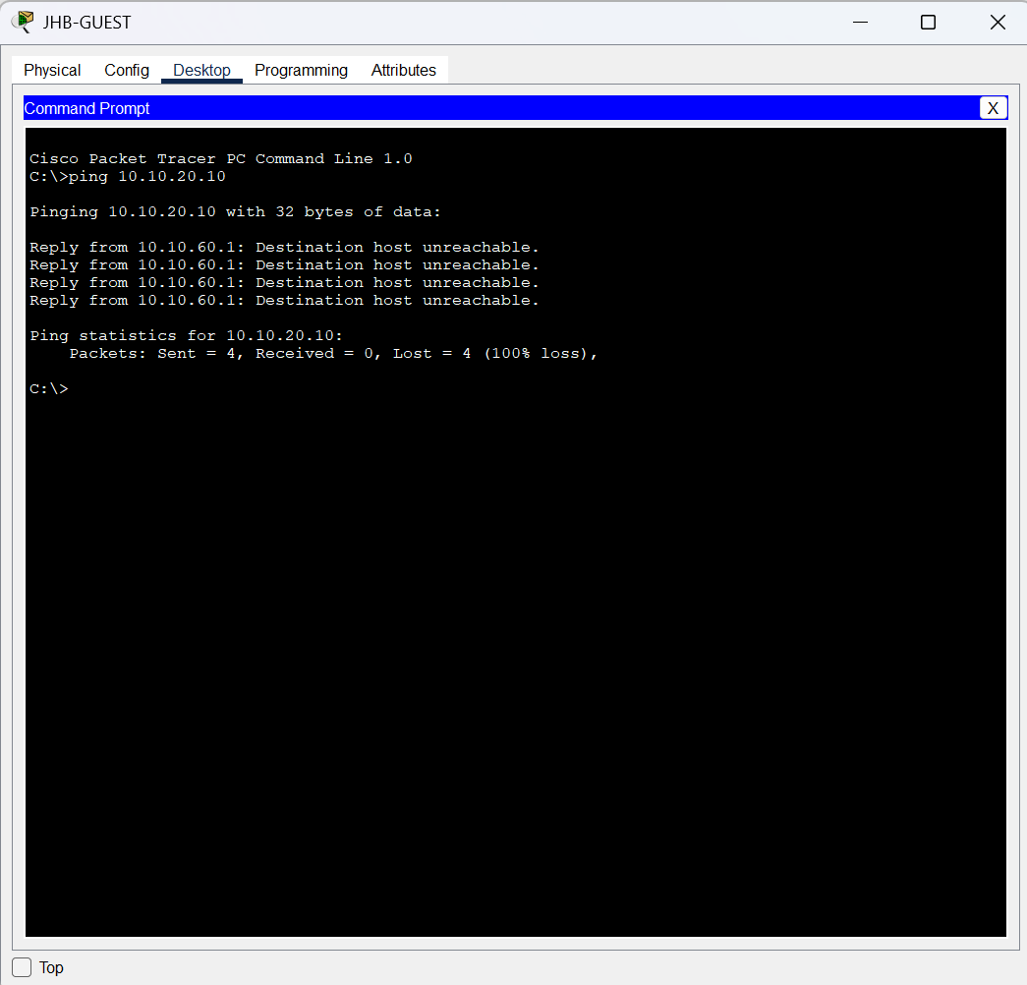
Figure 53: Guest security testing: checking that restricted internal destinations are blocked.
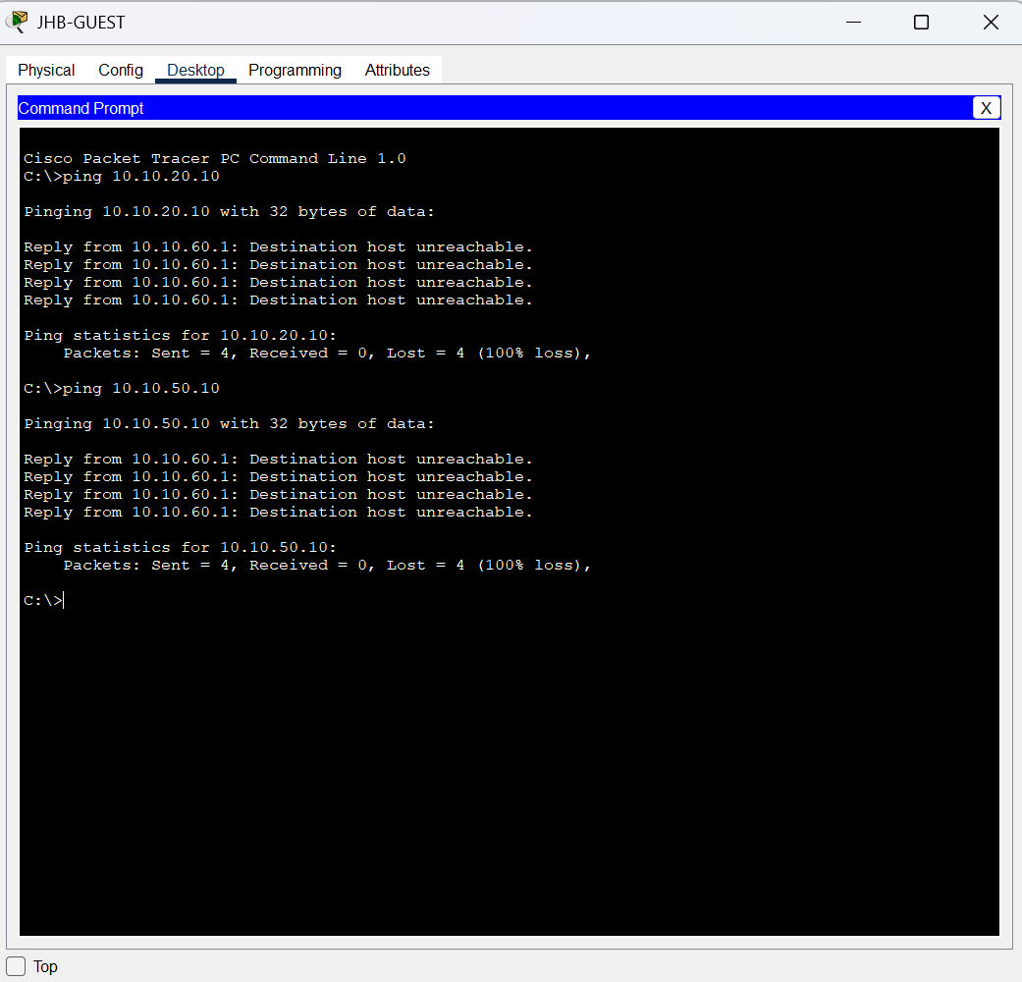
Figure 54: Guest security testing: verifying permitted and restricted traffic.
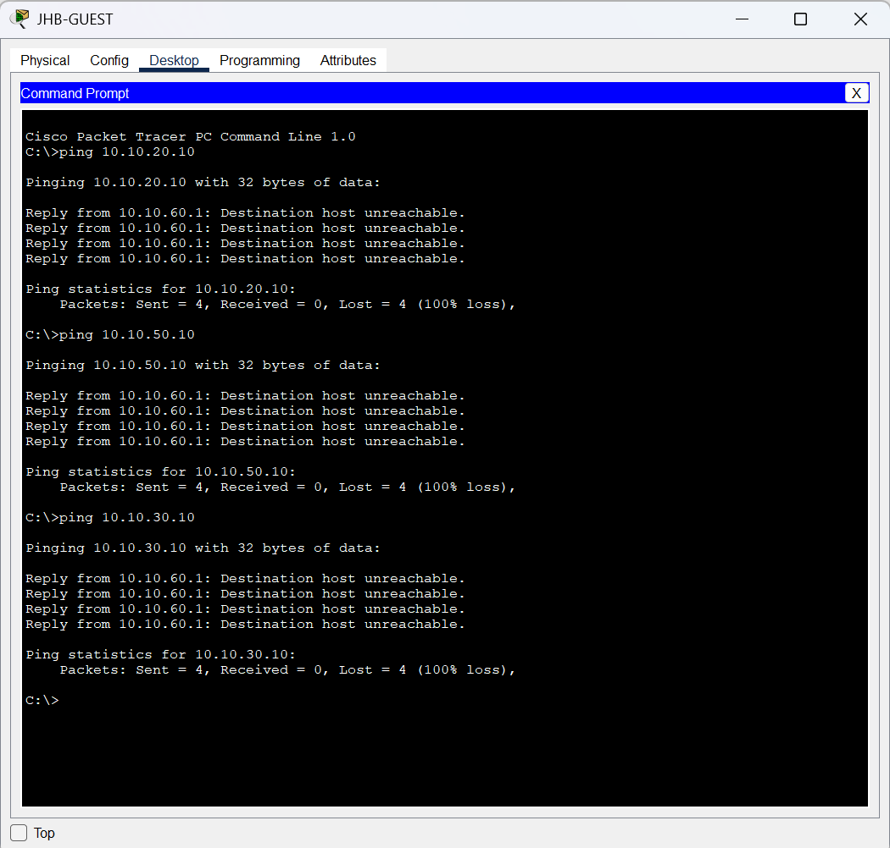
Figure 55: SSH security: configuring the router hostname/domain and local management access.
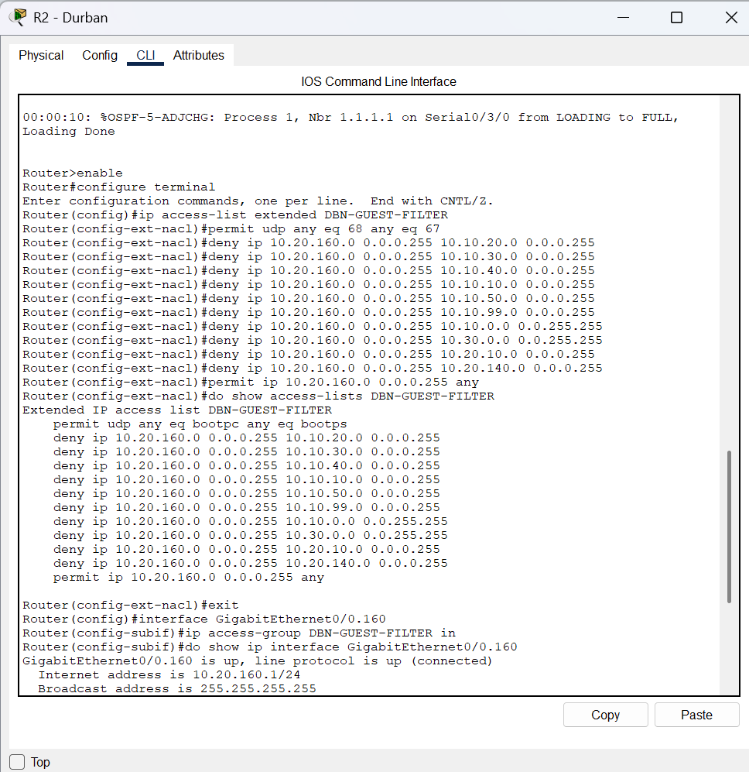
Figure 56: SSH security: configuring secure remote access on the router VTY lines.
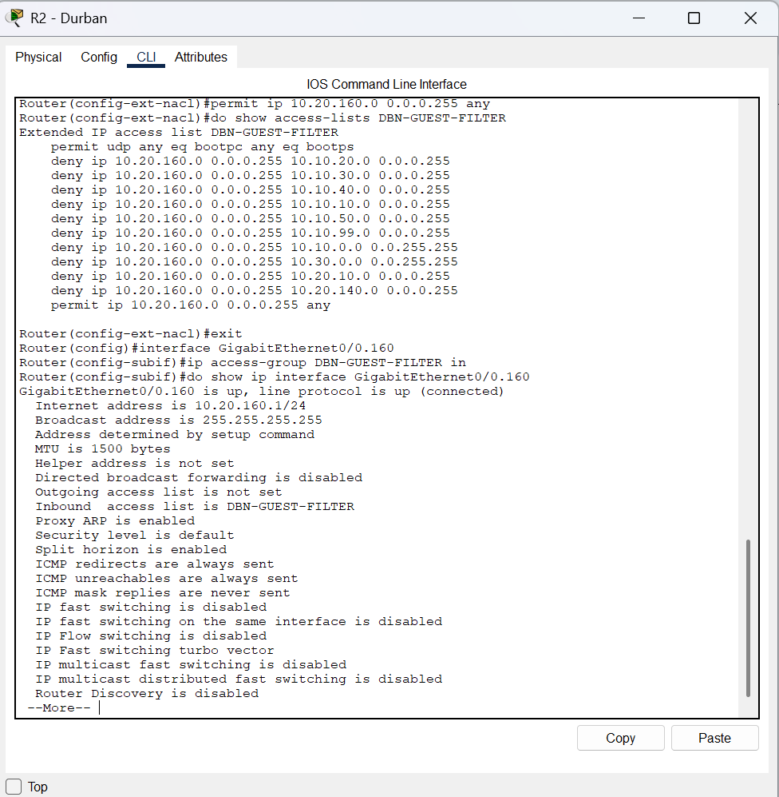
Figure 57: SSH verification: checking the SSH version and remote-management settings.
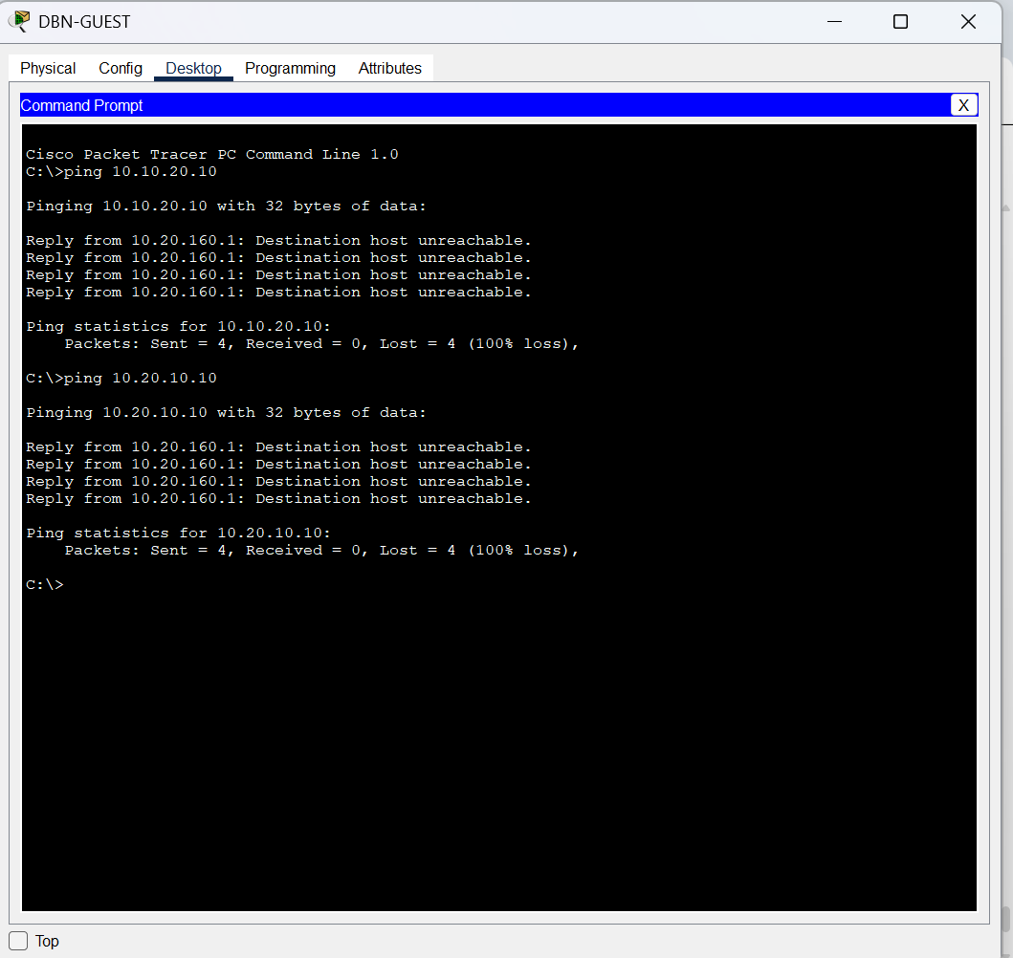
Figure 58: Router hardening: configuring the authorised-access warning banner.
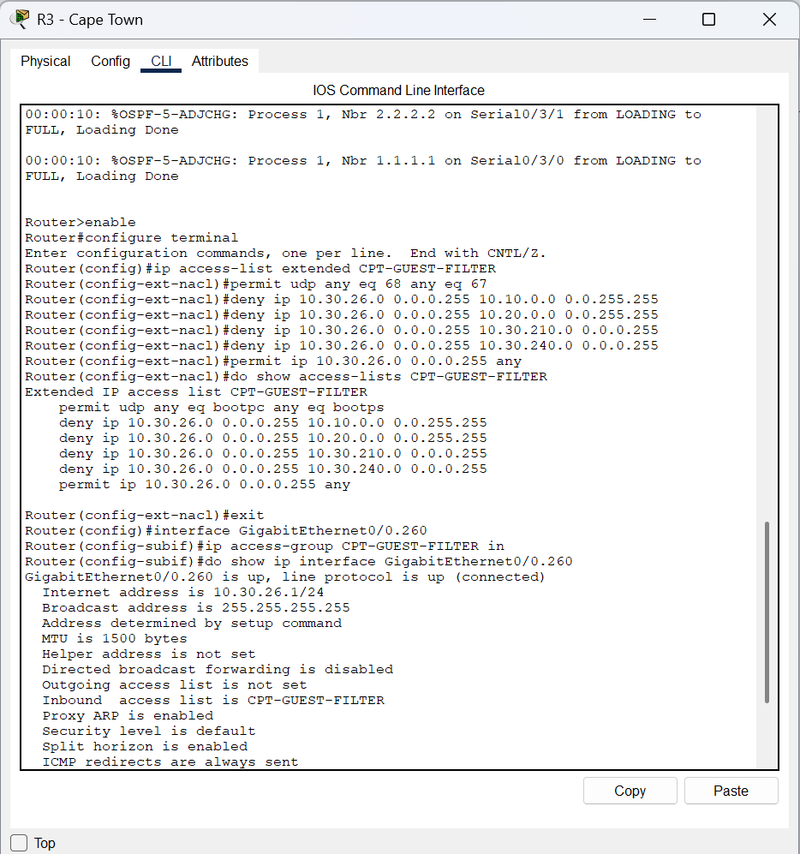
Figure 59: Router verification: checking interface status and IP addressing.
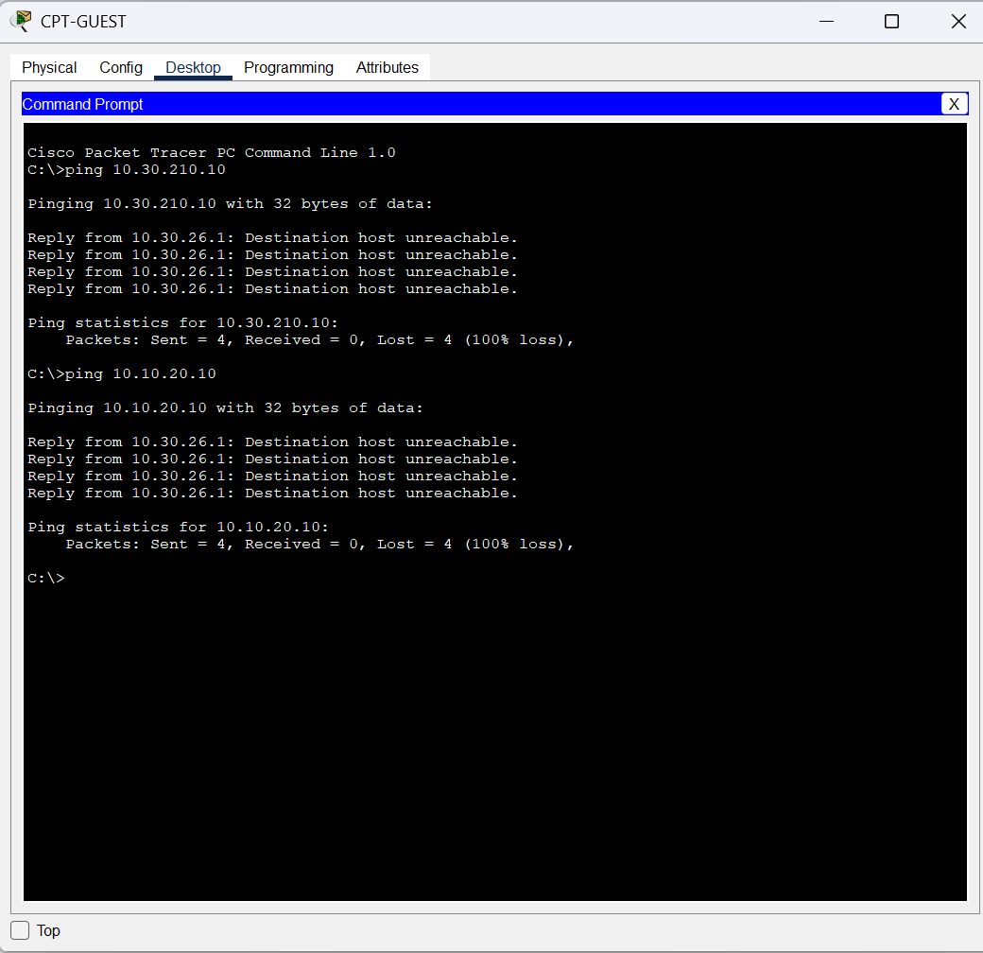
Figure 60: Server configuration: setting the internal server's network information.
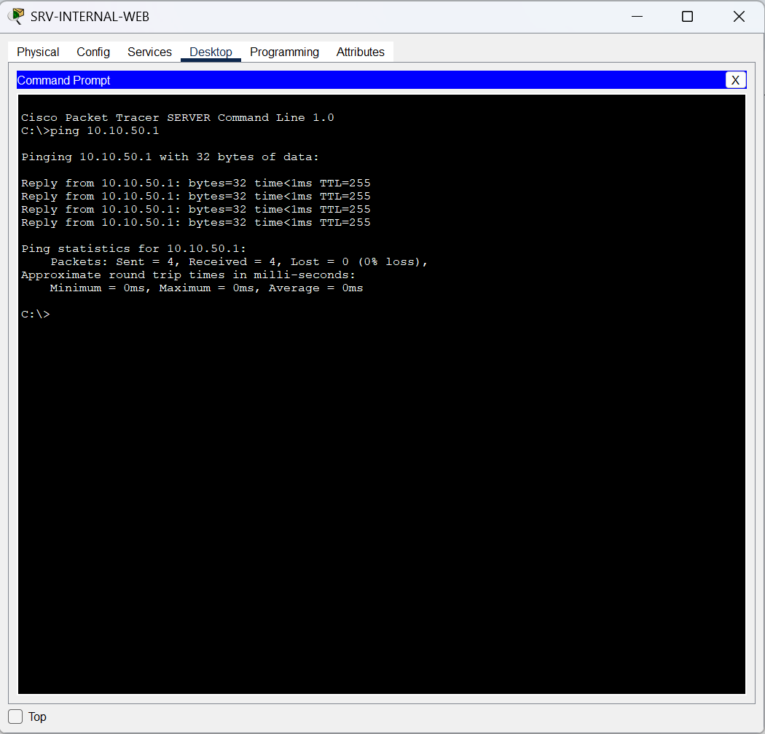
Figure 61: Server configuration: checking the internal web/DNS service settings.
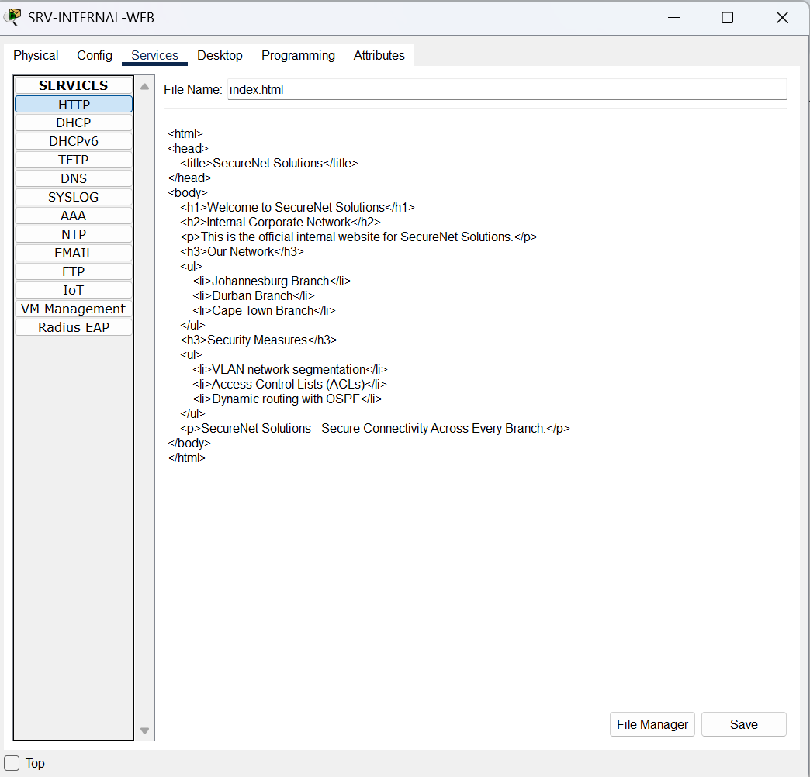
Figure 62: Server testing: checking connectivity to the internal server.
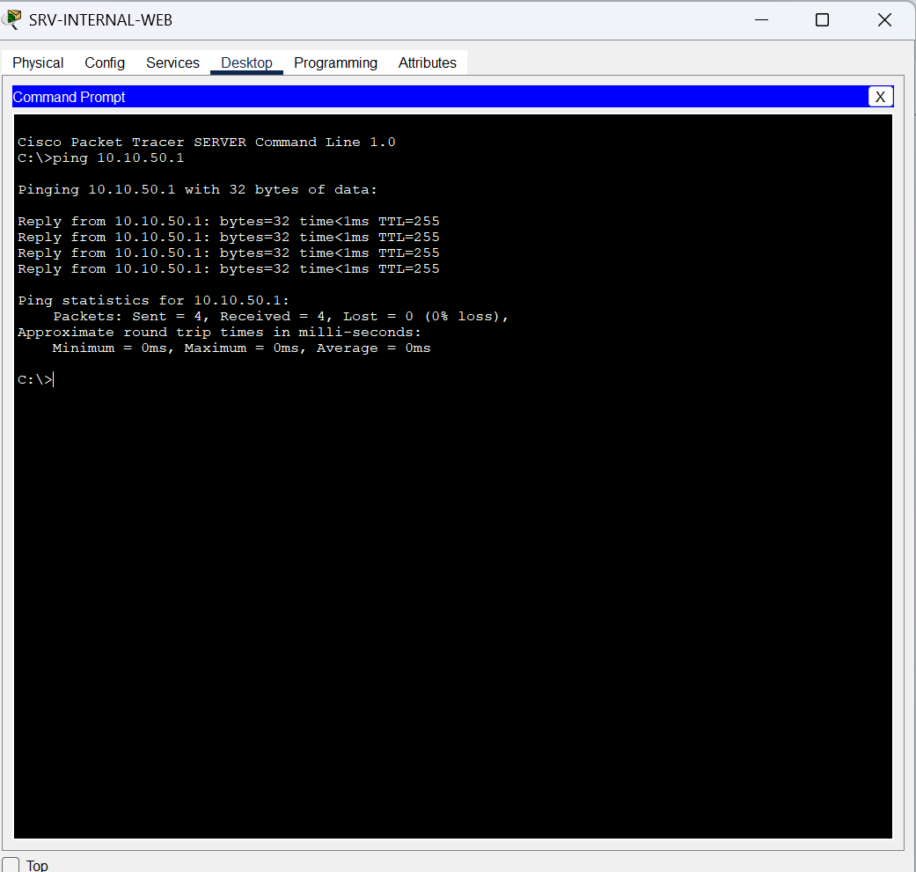
Figure 63: Internal web testing: opening the intranet page by IP address.
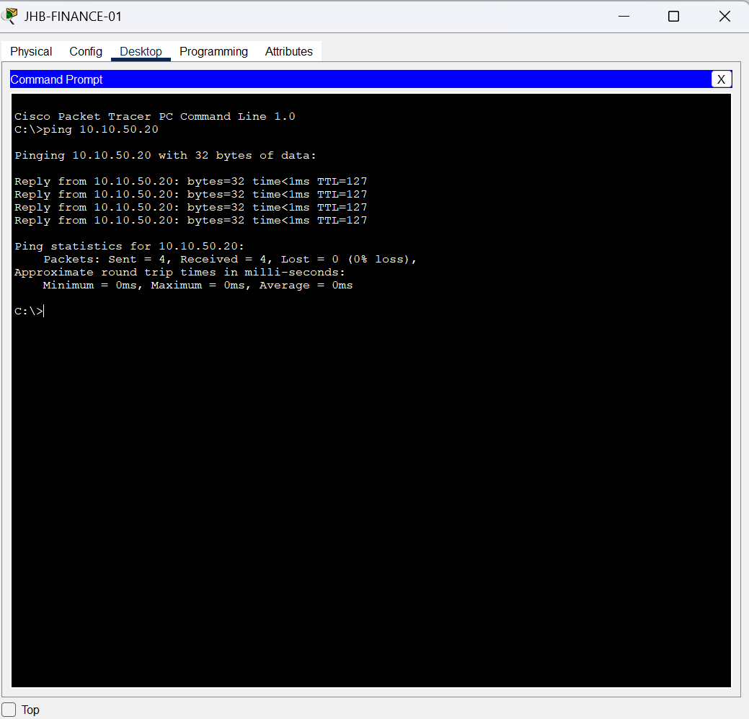
Figure 64: NAT configuration: configuring the Internet-edge inside/outside interfaces.
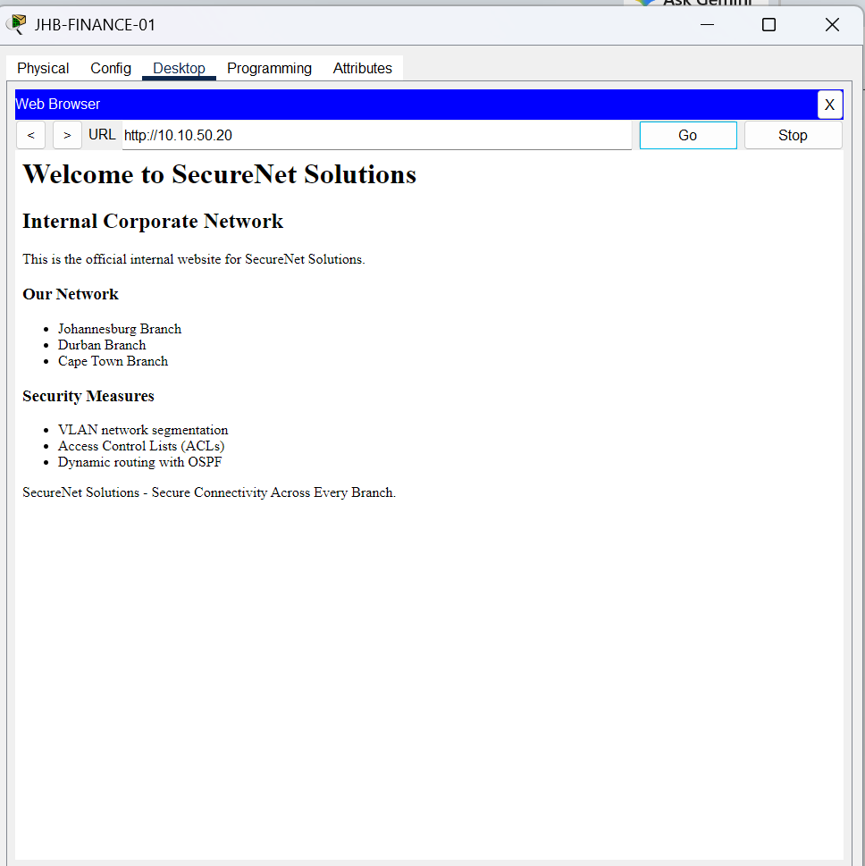
Figure 65: NAT configuration: configuring address translation for internal networks.
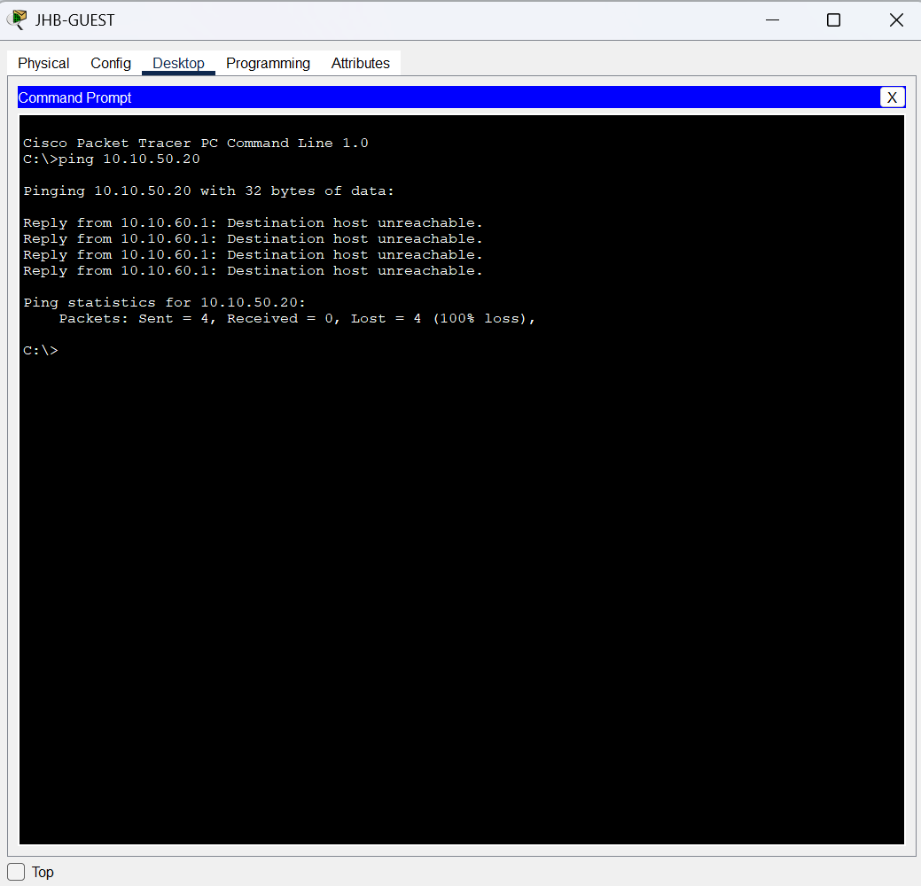
Figure 66: NAT verification: checking NAT translations and statistics.
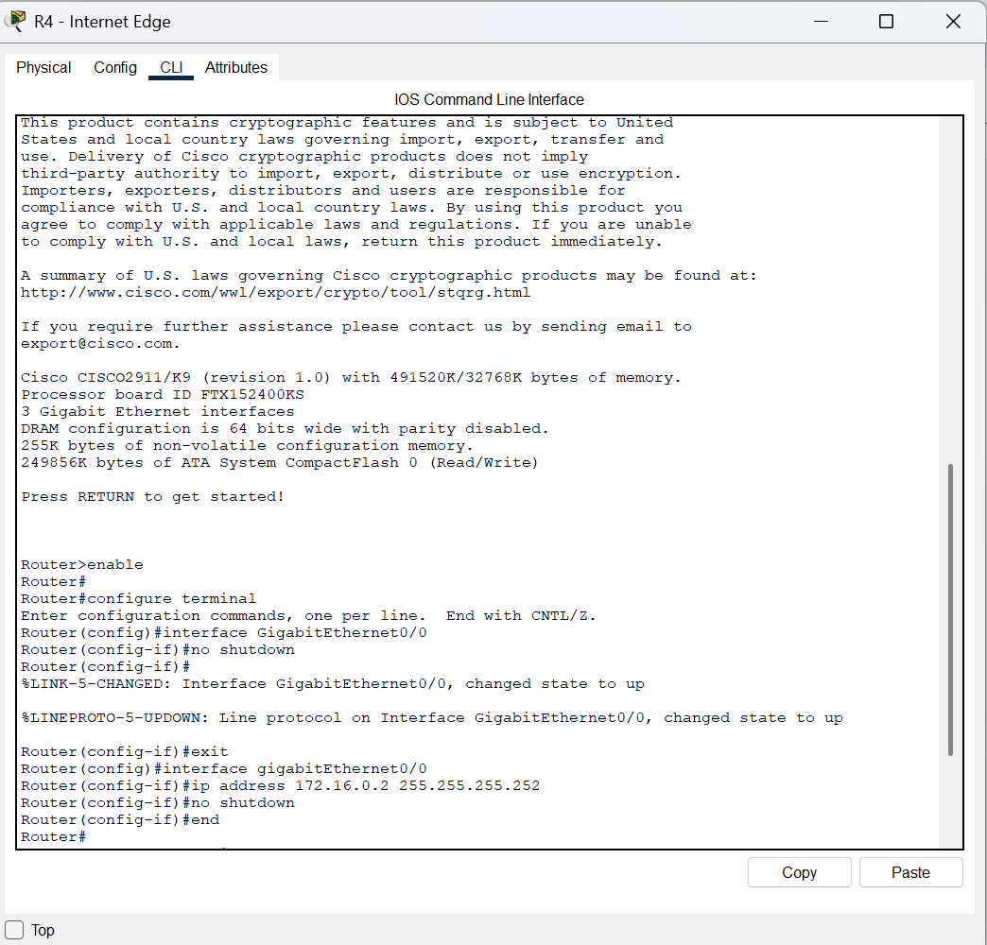
Figure 67: Internet-edge routing: checking the default route and return route.
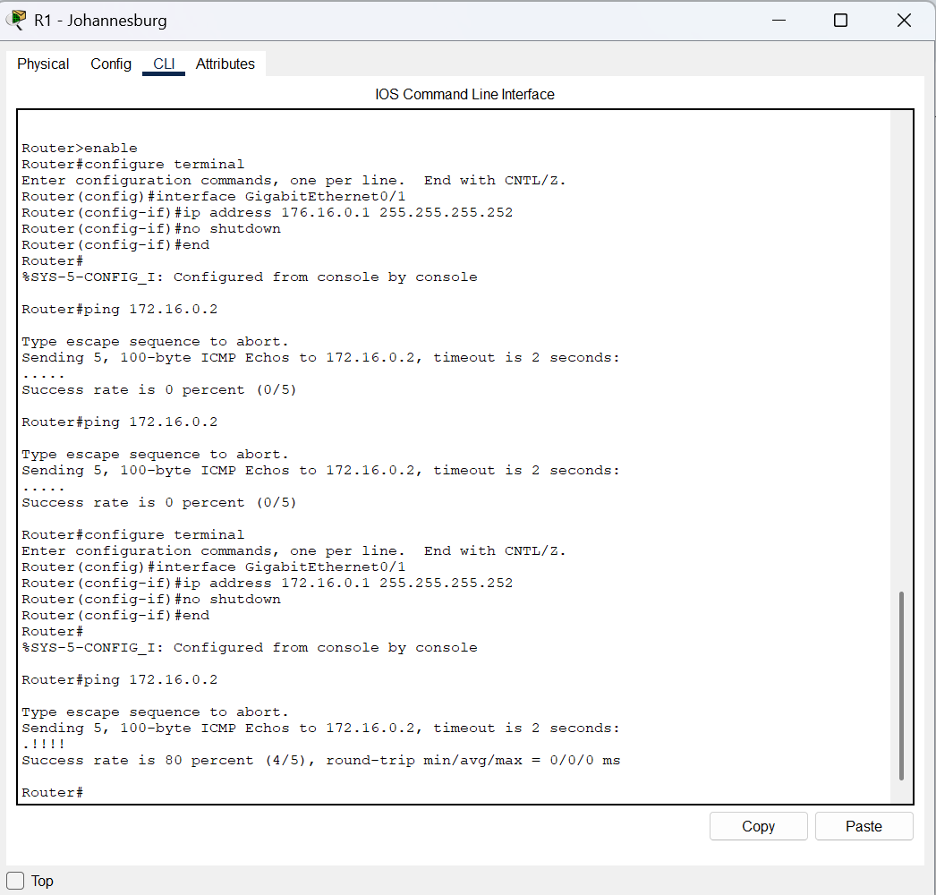
Figure 68: External connectivity testing: testing reachability to the external test server.
Figure 69: External connectivity testing: evidence of branch-to-external-server communication.
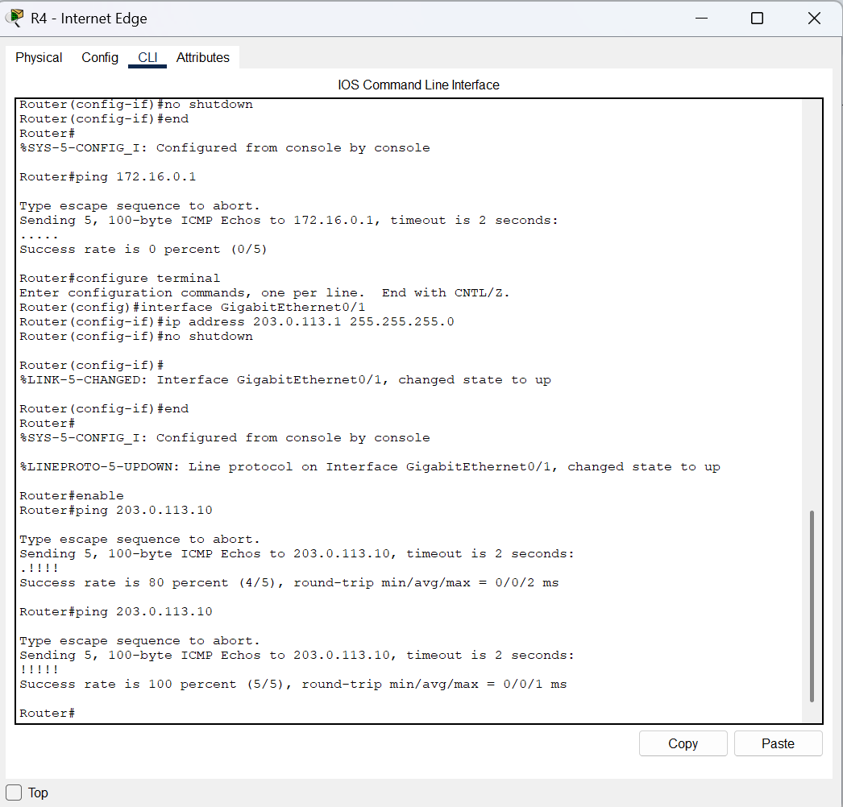
Figure 70: Troubleshooting: checking routing and connectivity after a failed test.
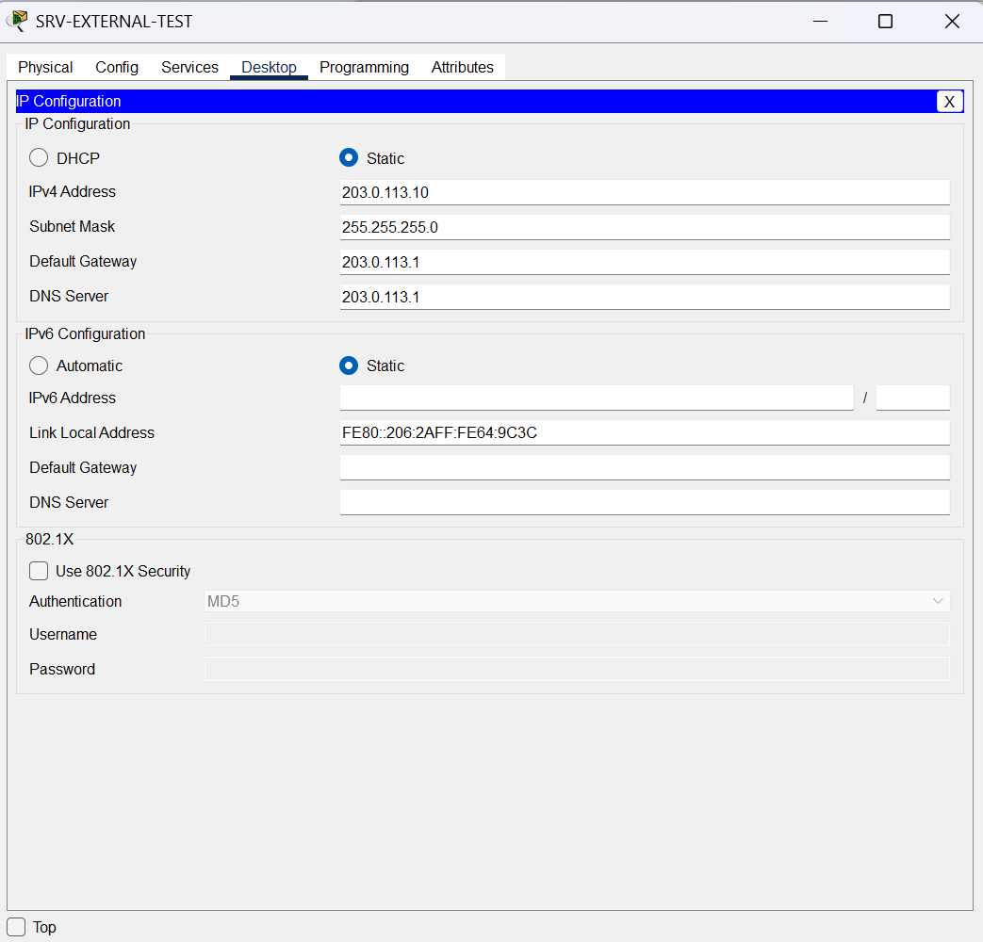
Figure 71: Troubleshooting: verifying the return path to internal branch networks.
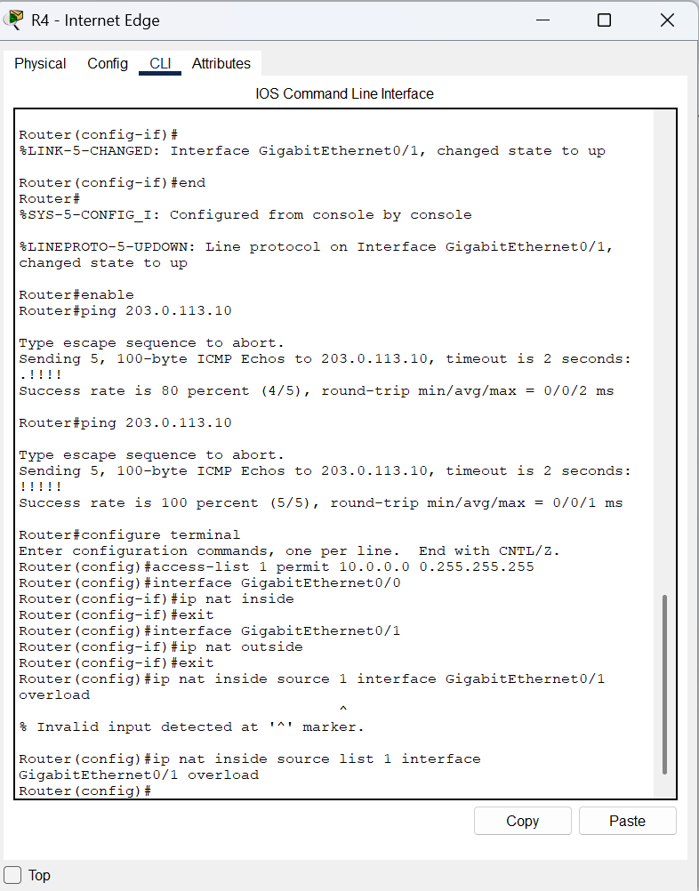
Figure 72: Final verification: checking the completed network configuration.
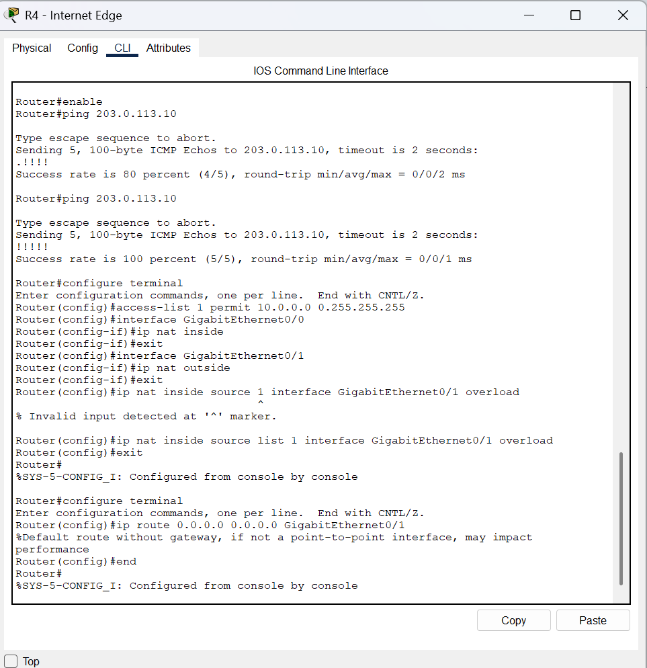
Figure 73: Final verification: reviewing routing and connectivity evidence.
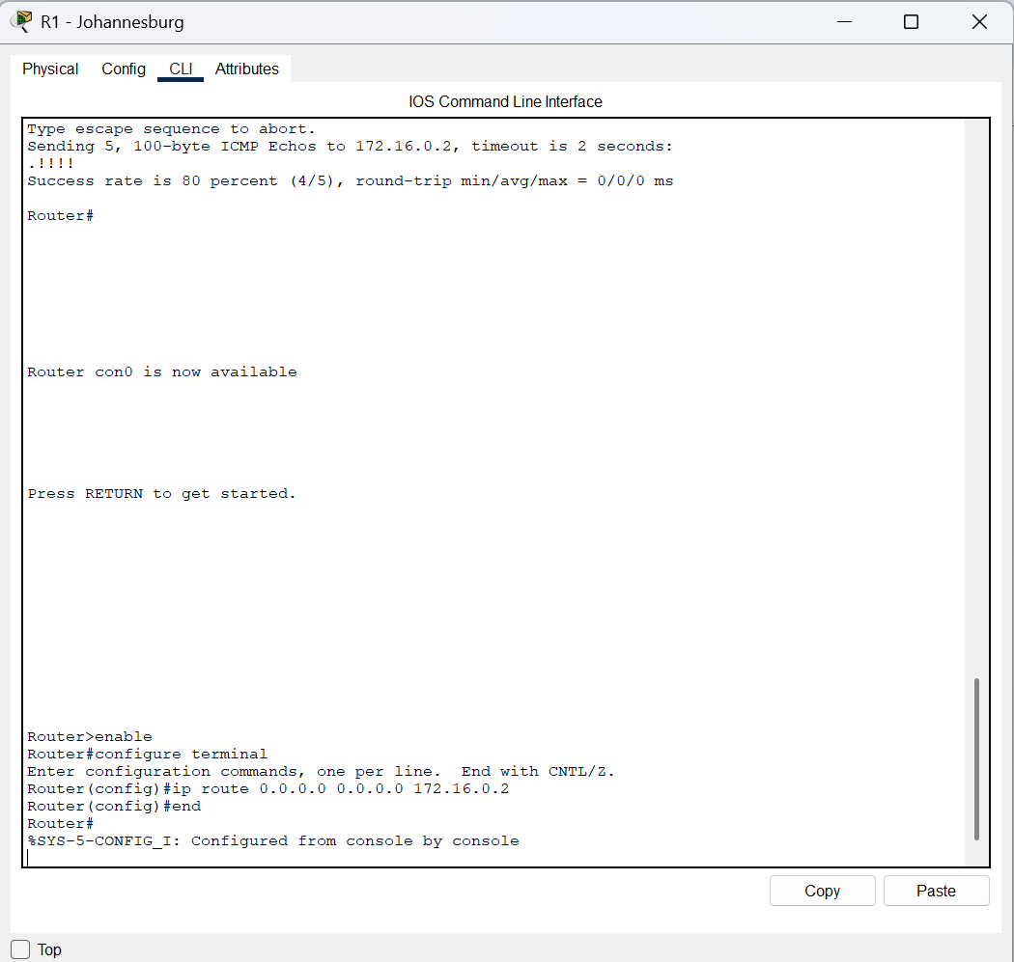
Figure 74: Final verification: reviewing DHCP, ACL, SSH, and server test evidence.
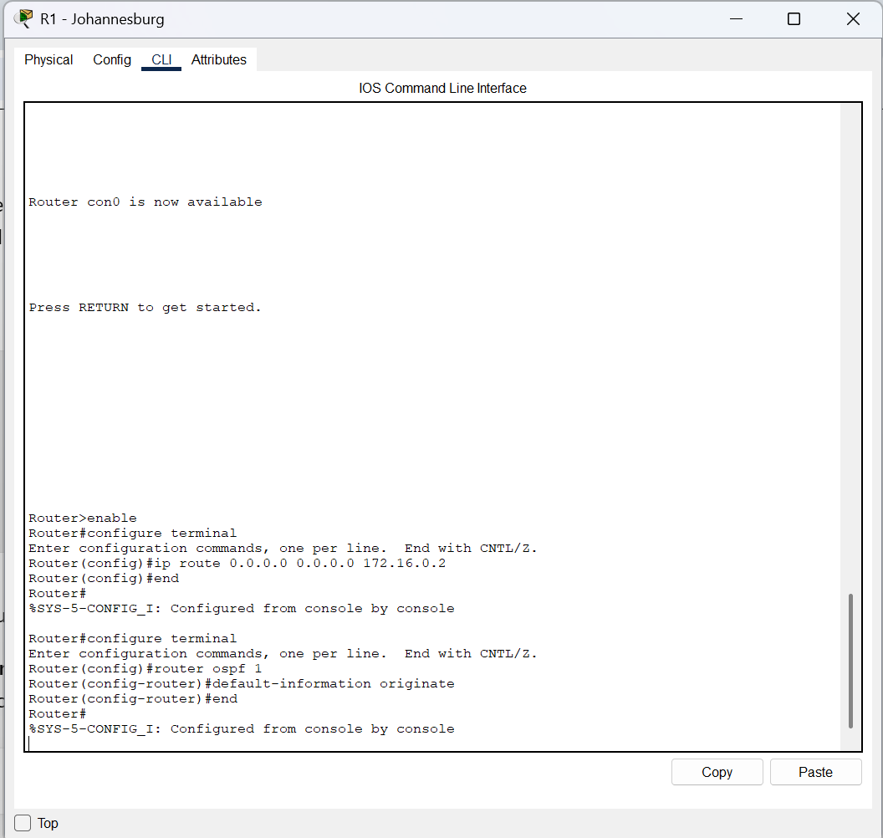
Figure 75: Final verification: additional command-line verification evidence.
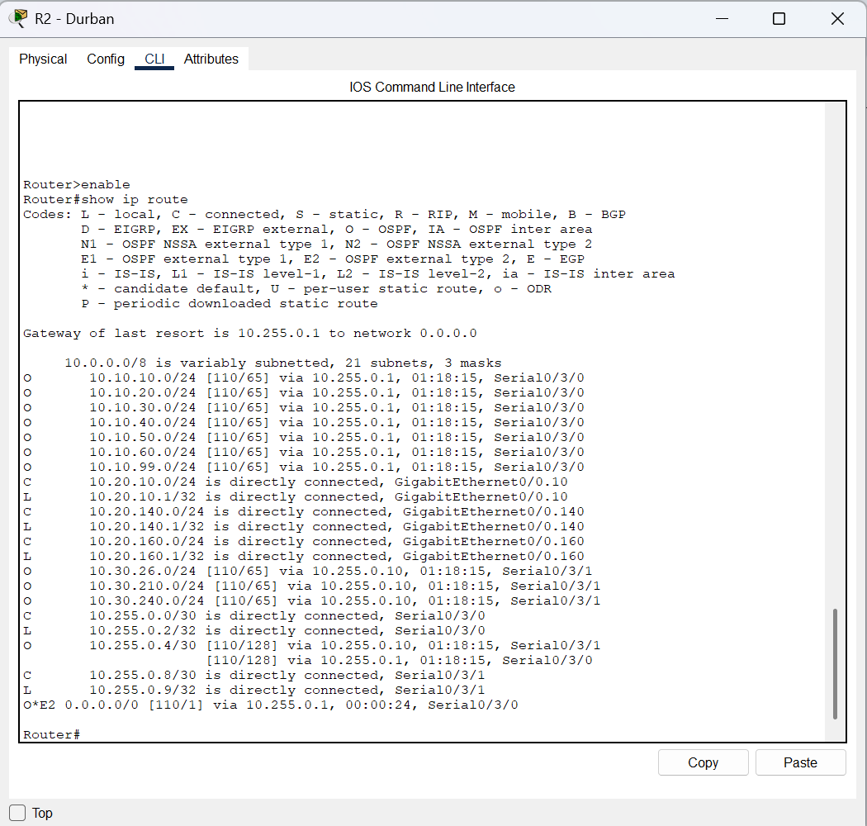
Figure 76: Final verification: additional command-line verification evidence.
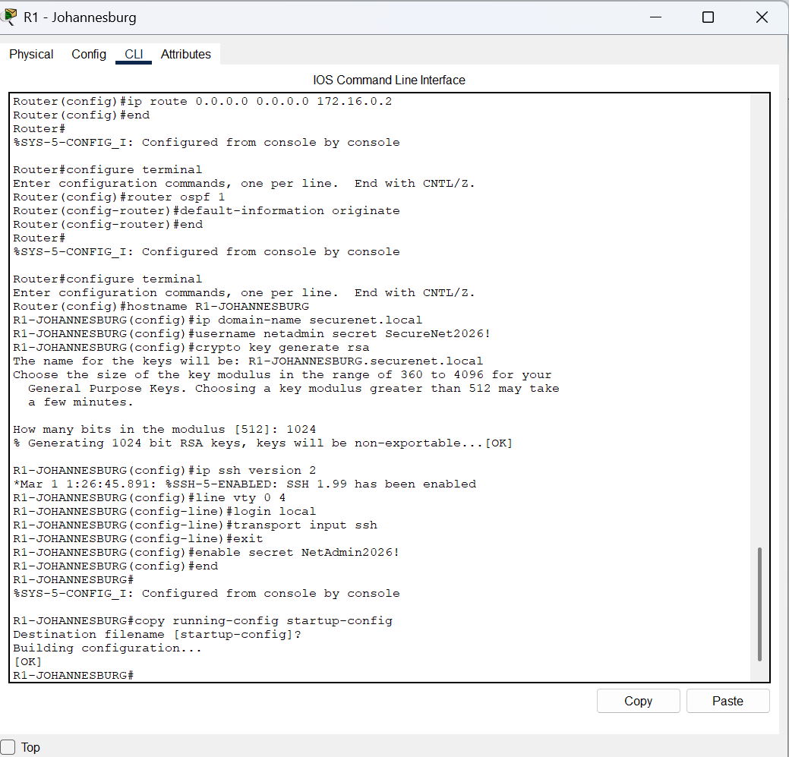
Figure 77: Final verification: additional command-line verification evidence.
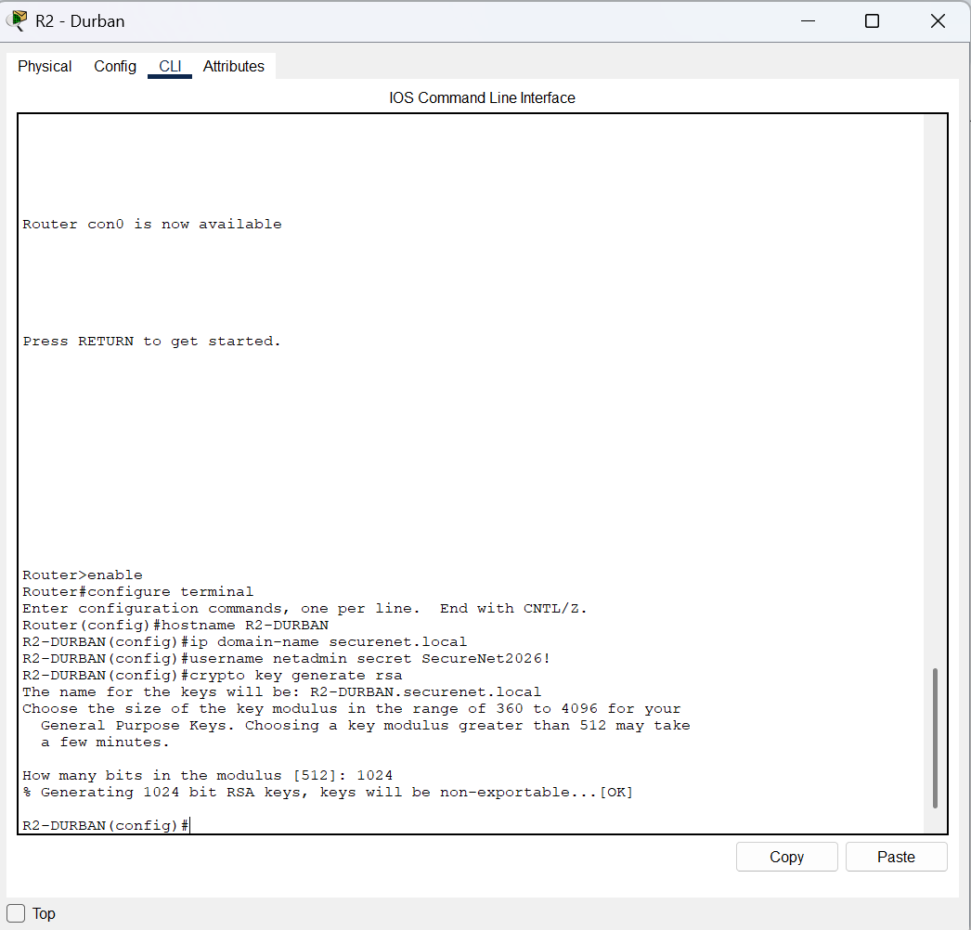
Figure 78: Final verification: additional command-line verification evidence.
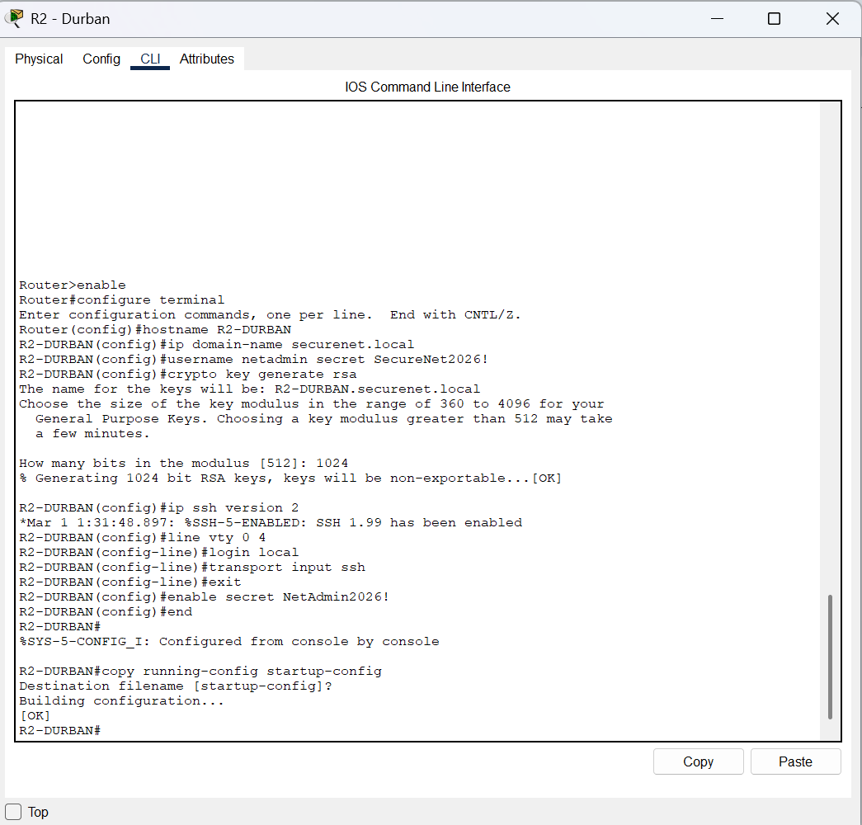
Figure 79: Final verification: additional command-line verification evidence.
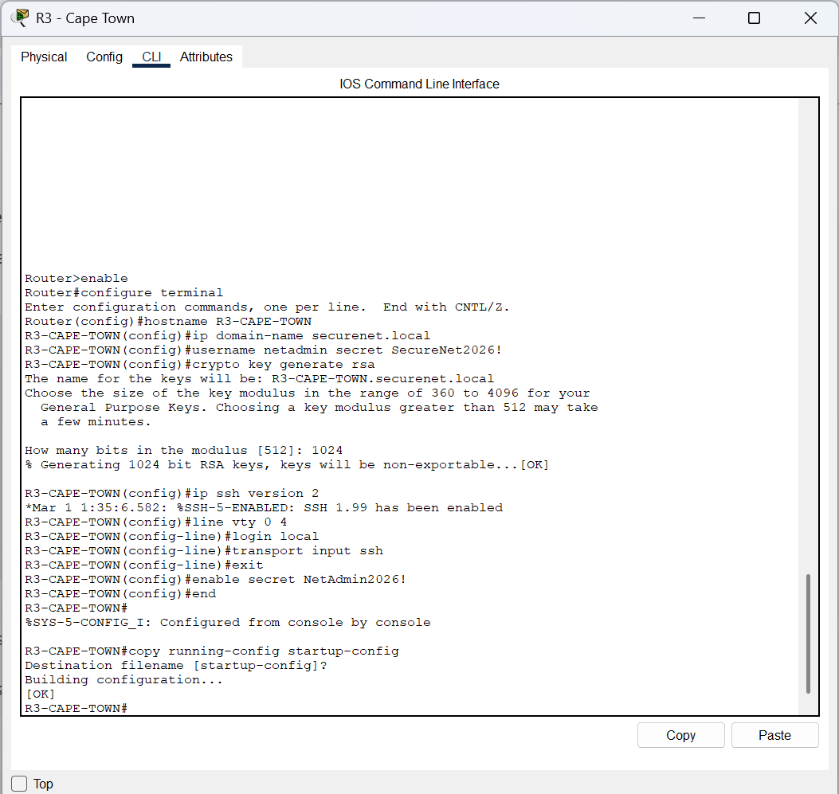
Figure 80: Final verification: additional command-line verification evidence.
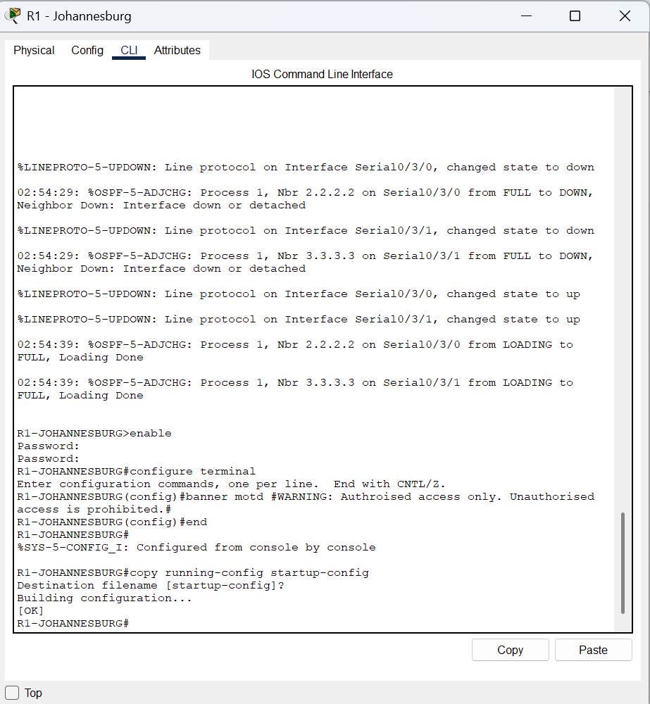
Figure 81: Final verification: additional command-line verification evidence.
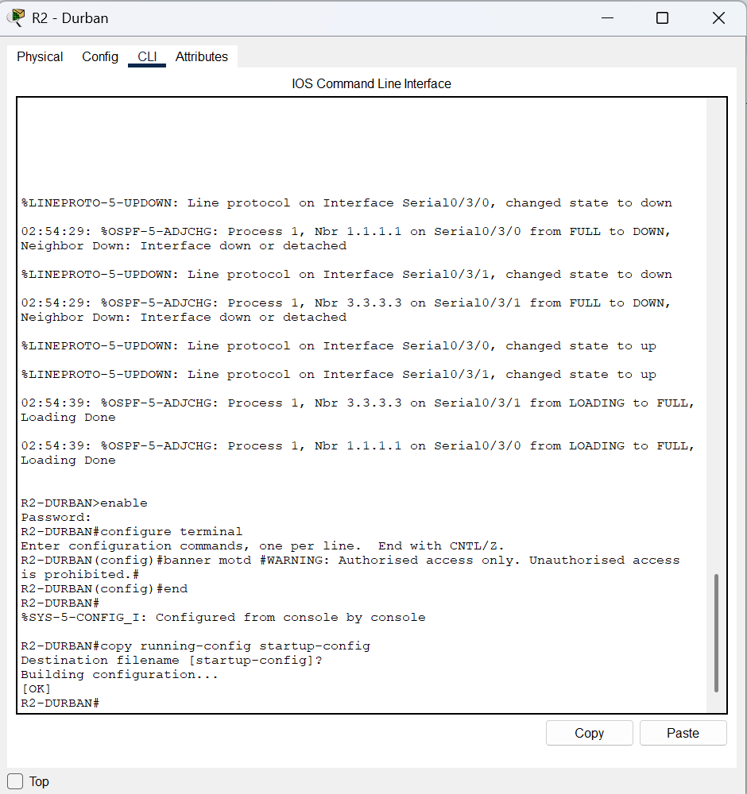
Figure 82: Final verification: additional command-line verification evidence.

